Facilitator Guide for

PHASE 1: RESEARCH AND ASSESS

Facilitator Guide for IET Design Camp
Phase 1: Research and Assess

Introduction
Welcome to the Facilitator Guide for the virtual or in-person delivery of the IET Design Camp, Phase 1: Research and Assess. This Guide outlines everything you need to know to facilitate the training, including logistics, training materials, learning objectives, timing, and talking points for each slide. Training teams should carefully go through this Guide and the corresponding training materials (see below) and make any necessary modifications.

Logistics
Date: [ENTER DATE]
Time: [ENTER TIME AND TIME ZONE]
Estimated Run Time: 2 hours [EDIT ESTIMATED TIME AFTER CUSTOMIZING SLIDES]
Technical Assistant: [ENTER TECHNICAL ASSISTANT NAME]
Moderator(s): [ENTER MODERATOR NAME(S)]
Trainers/Facilitators: [ENTER TRAINER/FACILITATOR NAME(S)]

Overview
In Phase 1: Research and Assess, participants will learn about the importance of selecting an IET program based on community and learner needs and will be introduced to the tools and techniques they will use to conduct their own community assessment. In addition, participants will learn how to synthesize what they learn from their research, identify key insights, brainstorm potential IET solutions, and identify a solution that is desirable, feasible, and viable.

Training Materials
- PowerPoint Deck: 1.A2_Research_Assess_PPT.pptx
- Participant Guide: Participant_Guide.docx
- Breakout Group Activity File(s): 1.B1_Research_Assess_Breakout_2_Facilitator_Handout.docx
Toolkit Sections Covered in this Session
- Research and Assess
- 1.1 Conduct a Needs Assessment
- 1.2 Identify Key Insights from Your Assessment
- 1.3 Brainstorm and Select an IET Program Opportunity
- Desk Aids
- IET Assess Tool
- Needs Assessment Note-Taking Tool

Objectives
After completing this session, participants will be able to:
- Recall the four key tasks for the Research and Assess phase.
- Explain the value of conducting an IET needs assessment before selecting an IET program.
- Identify the four key activities of an IET needs assessment.
- Identify the five key areas to research as part of an IET needs assessment.
- Use the Needs Assessment Note-Taking Tool and IET Planning Tool to plan an IET program that meets the needs of the community, including learners, partners, businesses, and workforce development.
- Develop a plan to conduct a local IET needs assessment.
- Develop a plan to synthesize learnings from the IET needs assessments, brainstorm. solutions, and select an IET program for development.
- Identify state and local IET-related policies.

1-0 Phase 1 Introduction
Start Time: [ENTER TIME]

Welcome and Introduction to the Training Session
Presenter: [NAME]
Duration: 2 min.
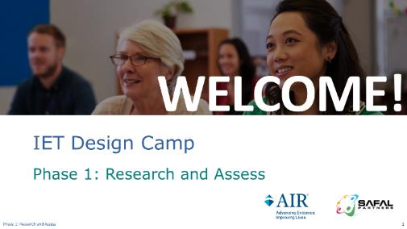
Present:
- Welcome participants to the session.
- Introduce yourself and talk about the IET Design Camp briefly.
- Welcome to Phase 1 of the IET Design Camp, which will cover the Research and Assess phase.
- You may want to open your Participant Guide to take notes or refer to any questions you had during your Toolkit reading assignment.
NEXT SLIDE

Virtual Meeting Recording Notice (OPTIONAL)
Presenter: [NAME]
Duration: 1 min.
NOTE – IET Design Team:
- This is an optional slide. If you are delivering the training in person or do not need a recording notice, delete this slide from this Guide and the PowerPoint deck.

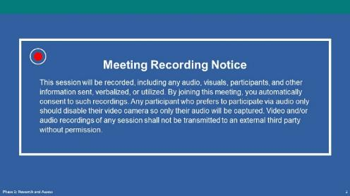
Present:
- Remind people that we will record today’s session.
NEXT SLIDE

Virtual Classroom Reminders (Optional)
Presenter: [NAME]
Time: .5 min.
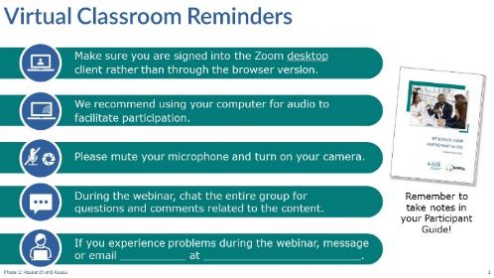
NOTE – IET Training Team:
- This is an optional slide. If you are delivering the training in person, delete this slide from the PowerPoint slide deck and from this Facilitator Guide. If you are delivering the training on another platform, edit this slide accordingly.
Present:
- Review virtual classroom reminders.
- Please take a moment to read through these reminders and make sure you’re ready to participate in the session.
- You may want to open your Participant Guide to take notes or refer to any questions you had during your Toolkit reading assignment.

Agenda
Presenter: [NAME]
Duration: 1 min.
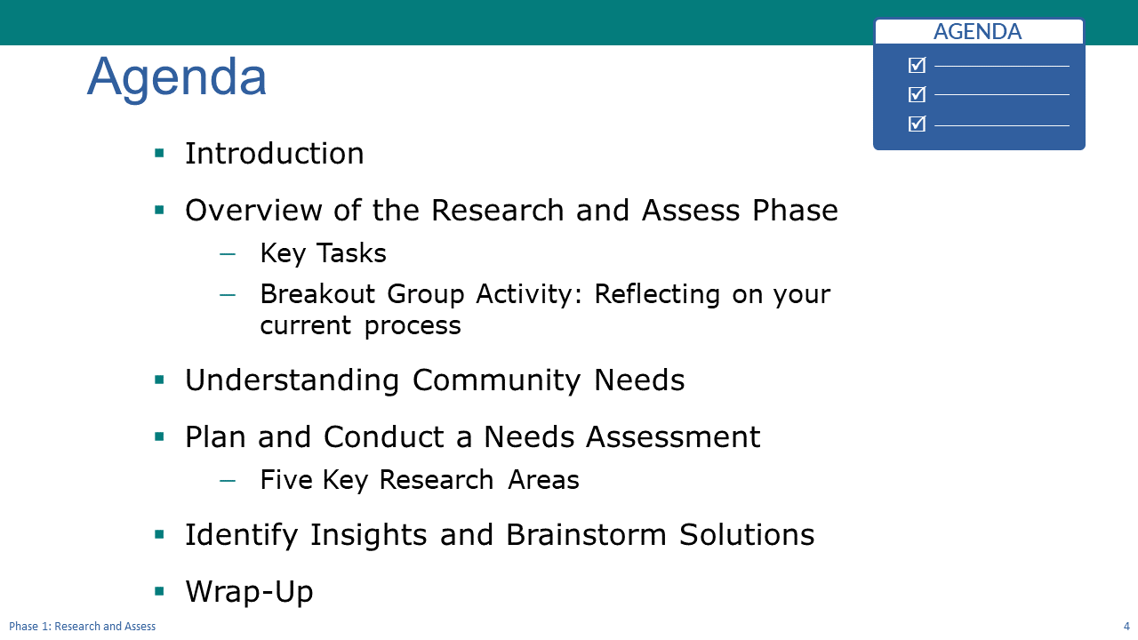
Present:
- Review the agenda
- We’ll start today’s session by reflecting on the Research and Assess section of the Toolkit, and then we’ll take a quick poll and follow up with a breakout group activity where you’ll discuss the process you currently use or recently used to identify an IET program opportunity.
- Next, we’ll discuss the importance of taking the time to gain an understanding of your community’s needs before embarking on developing an IET program. We’ll also introduce the IET Assess Tool, which is a valuable resource for your team during this phase.
- Then we’ll move into the Plan and Conduct a Needs Assessment topic where we’ll explain what a needs assessment is and talk about the four activities that comprise a needs assessment. We’ll discuss five key areas to assess, and we’ll have another activity where you’ll explore one of the key areas and practice applying some of the concepts we’ve been talking about.
- We’ll briefly touch on identifying insights from your needs assessment and brainstorming solutions to meet the identified needs through an effective IET program.
- We’ll wrap up the session with some key takeaways and next steps.
- Transition to next slide.
- Let’s introduce your trainer(s) for today’s session.
NEXT SLIDE

Today’s Trainers
Presenter: [NAME]
Duration: 1 min.
Present:
- Introduce the trainers or have them introduce themselves.
NEXT SLIDE

IET Design Camp – We are Here
Presenter: [NAME]
Duration: 2 min.
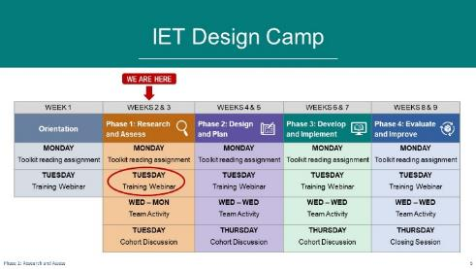
NOTE – IET Training Team:
You should have already developed a table that reflects the structure and organization of your Design Camp for the Orientation session. You may want to just copy and paste your table onto this slide and move the “WE ARE HERE” and arrow to the Phase 1 session.
Present:
- Briefly review the structure of the Design Camp and orient participants to where you are—Phase 1. Tailor your talking points to reflect the design and schedule of your training (e.g., you may not be doing a cohort meeting.)
- As we discussed in the Orientation, the IET Design Camp is broken into an Orientation and four phases. In each phase, there is a read-ahead, a training session, a team activity, and a cohort meeting, or in the case of the last phase, a closeout session.
- Today we’re kicking off Phase 1: Research and Assess. Hopefully, you’ve had a chance to read the Research and Assess phase of the IET Toolkit over the last week.
- Today is our first training session. You’ll have about a week to do your team activity, and we’ll meet again next [ENTER DATE], for your first cohort meeting (if applicable).
- Let’s get started.
NEXT SLIDE

Key Tasks for Research & Assess Phase
Presenter: [NAME]
Duration: 1 min.
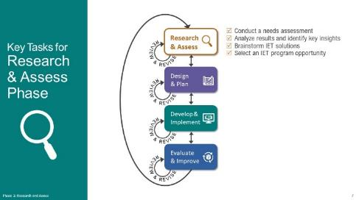
Present:
- Briefly describe what happens in the Research and Assess Phase
- Phase 1 focuses on the importance of selecting an IET program based on the needs of the community, including learners, partners, employers, businesses, and workforce development. We’ll share some tools and techniques to conduct a needs assessment to identify a solution that is desirable, feasible, and viable and meets community needs.
- Keep in mind that we’re sharing one way to approach this work. You may have other processes and procedures in place or planned. It can be helpful to recognize that this is an ongoing, iterative process and may require revisiting your plans.
NEXT SLIDE

Group Discussion – Reflect on Your Reading
Presenter: [NAME]
Duration: 4 min.
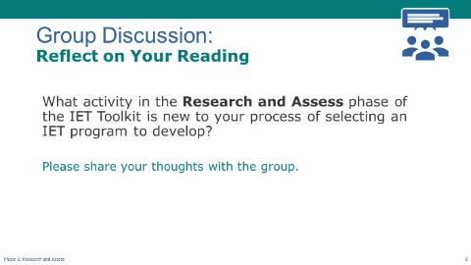
Discuss/Chat:
- Facilitate a discussion on the following question(s).
- What activity in the Research and Assess phase of the IET Toolkit is new to your process of selecting an IET program to develop?
- [Optional follow-up question] What seemed most likely to improve your current process?
- [If In-Person] Ask participants to raise their hand or call out responses.
- [If Virtual] Have participants share responses in the chat or unmute their microphone to speak.
NEXT SLIDE

Poll: Your Research Activities (Optional)
Presenter: [NAME]
Duration: 2 min.
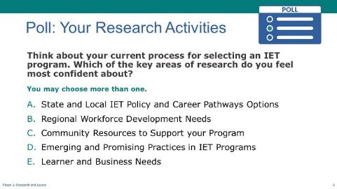
NOTE – IET Training Team:
- This is an optional poll designed to engage participants in the content for this session. You can delete or modify it as needed and adjust the time spent on discussion results according to your priorities.
Poll:
- Introduce the poll question and ask participants to respond.
- [If In-Person] Read the options and have participants raise their hands.
- [If Virtual] Ask the technical assistant to launch the poll and give participants a little time to respond, then ask the technical assistant to share the results.
- Discuss responses
NEXT SLIDE

Breakout Group Activity #1: Reflecting on your current process
Presenter: [NAME]
Duration: 13 min. (total)
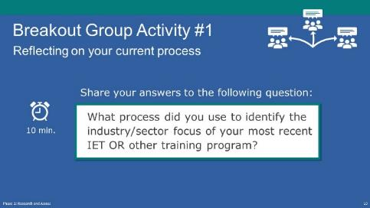
NOTE – IET Training Team:
- If you are conducting the training in person, this activity can be conducted in small groups, preferably with a group facilitator.
- If you are conducting the training virtually, you will need to have the technical assistant set up the required number of breakout rooms and assign participants and group facilitators to a room (See tech note below).
Present: (1 min.)
- Explain the activity.
- For this breakout group activity, briefly share with each other: What process or processes you’ve used in the past (or that you’re aware of) to identify the industry sector focus of your most recent IET or other adult training program.
- You’ll have about 10 minutes.
NOTE – Technical Assistant:
- If virtual, assign participants to one of the following breakout rooms:
- Room 1- [FACILITATOR(S) NAME(S)
- Room 2- [FACILITATOR(S) NAME(S)
- Room 3- [FACILITATOR(S) NAME(S)
- Room 4- [FACILITATOR(S) NAME(S)
- Room 5- [FACILITATOR(S) NAME(S)
Breakout Group Activity: (10 min.)
FACILITATORS:
- [If virtual] Place yourself in the correct room (see room assignments above).
- Facilitate a 10-minute discussion about the process they used to identify the industry sector focus of their most recent IET or other adult training program.
- Prompt participants to share whether they worked with other education or industry partners, leveraged the local or state WIOA plan, used student surveys or other learner input on interests, etc.
- Ask: Who conducted the outreach or scan? What type of documentation did you collect?
Allow 10 minutes for the discussion, then bring them back to the main room (if virtual).
Activity Debrief and Transition to Next Topic: (2 min.)
- Ask: Who wants to share the process someone else in their group used to identify the industry sector focus of their most recent IET or other adult training program?
- Now that we have reflected on your current practices, let’s dive into the approaches we’ll discuss today.

1-1 Understanding Community Needs
Estimated Start Time: [ENTER TIME]

Understanding Community Needs – Topic Intro
Presenter: [NAME]
Duration: 1 min.
Present:
- Introduce the topic and subtopics.
- For the next few minutes, we’re going to talk about why it’s important to understand community needs when selecting an IET program.
- We’ll talk about how IET programs fit into a broader ecosystem of training, education, and work-based learning within your community, and how it aligns with other offerings from the workforce system, community colleges, the private sector and more.
- And we’ll lay the groundwork for the repeatable process from the Toolkit for gathering information and using your understanding of community needs to select an IET program.
NEXT SLIDE

Importance of Conducting Research to Assess Community Needs
Presenter: [NAME]
Duration: 2 min.
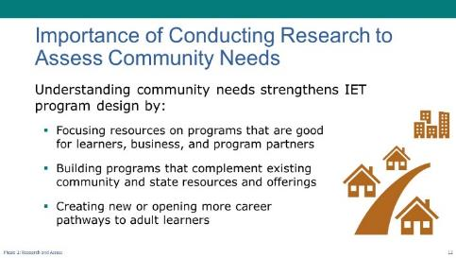
Present:
- Explain how understanding community needs strengthens IET program design.
- Understanding community needs strengthens IET program design because it helps you gain insights that allow you to tailor your program for your learners and your community to create value.
- When we use the word, “community,” we’re talking about the businesses, workforce development, adult education partners, and employers, as well as the adult learners in the local area.
- Doing this work is an investment of resources, and you want to build a program that meets the needs of your learners and businesses and strengthens your ability over time to provide programming that moves adult learners and partners forward.
- Look for ways to complement and not duplicate other community offerings. It can help open new or more career pathways.
- Learning about your community needs promotes diversity in training and career pathways opportunities for individuals who may not have access to more traditional career opportunities.
- It can help adult learners enter the workforce more quickly than sequential programming.
- And it helps local employers by developing qualified applicants who have the knowledge and skills needed to build their workforce.
NEXT SLIDE

Developing IET Programs that are Desirable, Feasible, and Viable
Presenter: [NAME]
Duration: 2 min.
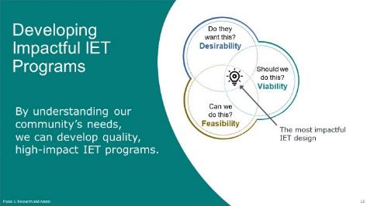
Present:
- Speak to the Venn diagram on the slide.
- IET programs represent a significant investment of time and resources on the part of you, your partners, and your funders. Any program you develop you want to make sure it hits the sweet spot, represented by the intersection or white spot on the Venn Diagram, between desirability, feasibility, and viability.
- Desirable means that you’re meeting learner, business, and community needs – Do they need it, and will they access it?
- Feasible means you have the operational capacity to design and deliver the program – that the funding, partnerships, and interested learners are there – Can we do it?
- Viable means this work aligns with the broader goals of your adult ed and potentially your partners’ programs and can be supported and sustained – Should we do it?
- Understanding community needs helps you answer these questions.
NEXT SLIDE

Complementing Other Community Offerings
Presenter: [NAME]
Duration: 2 min.
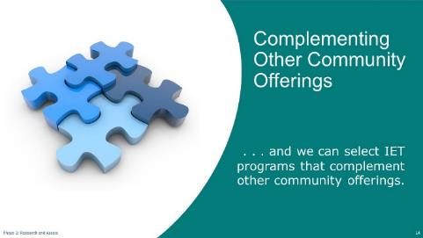
Present:
- Talk about selecting IET programs that complement other community offerings.
- Quality IET programs fit into a broader regional network of workforce development, education, and training offerings.
- By understanding community needs, you are part of this larger ecosystem, not outside it.
- Align to other career pathways strategies led by workforce development and education partners including apprenticeships, pre-apprenticeships, bridge programs, incumbent worker trainings, on-the-job trainings, industry partnerships and additional postsecondary training.
- The idea here is that you don’t want or need to start from scratch. If your partners are implementing a specific occupational training program, you may want to explore leveraging an add-on or expansion to that training for an IET. And even if the need is for a new occupational focus, there may be lessons and experience to leverage from existing apprenticeship or incumbent worker programs, or other types of training strategies.
NEXT SLIDE

A Repeatable Process
Presenter: [NAME]
Duration: 3 min.
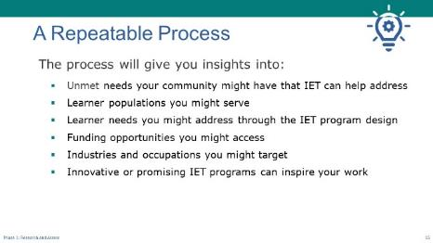
Present:
- Use the slide to explain how the repeatable process will provide valuable insights.
- We’re going to introduce you to a repeatable process you can use to assess needs in your community so you can select a viable, desirable, and feasible IET program that will meet community needs and underscore your value in the broader workforce development system.
- The process will give you insights into the questions on the slide.
- What unmet needs does our community have that IET can help address?
- What learner populations might we serve?
- What learner needs might we address through the IET program design?
- What funding opportunities might we access?
- What industries and occupations might we target?
- What innovative or promising IET practices did we learn about that might benefit our community?
- What partners do we need for this work?
- Next, we’re going to walk through the Assess Tool and talk through the needs assessment.
NEXT SLIDE

The Assess Tool
Presenter: [NAME]
Duration: 3 min.
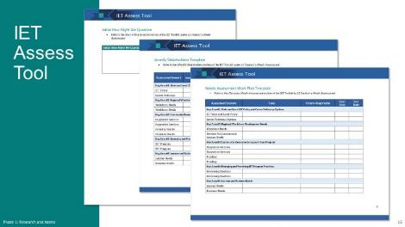
Present:
- Describe the Assess Tool and how to use it.
- The research and Assess phase of the toolkit contains an IET Assess Tool.
- This tool provides a structure for designing your research plan, collecting information, and supporting your analysis as you walk through activities in the Research and Assess phase of the IET Toolkit.
- For example, the tool provides a template for capturing stakeholders in your work as well as a work plan template.
- You can download this tool to capture your work from the different sections of this phase.
- You don’t have to complete all sections of the tool; it’s designed to lay out all the possible areas to explore, but we recognize you need to fit your assessment into the time and resources you have.
NEXT SLIDE

Questions? (Understanding Community Needs)
Presenter: [NAME]
Duration: 4 min.
Present:
- Ask if there are any questions about the importance of understanding community needs before deciding on an IET program.
NEXT SLIDE

1-2 Plan and Conduct a Needs Assessment
Estimated Start Time: [ENTER TIME]

Plan and Conduct a Needs Assessment – Topic Intro
Presenter: [NAME]
Duration: 1 min.
Present:
- Introduce the topic and subtopics.
- Now we’re going to look more closely at a process for assessing needs.
- We’ll also go over the five key areas you’ll want to assess.
- We’ll finish this topic with an activity where you’ll explore one of the key areas and apply some of the concepts we’ve been discussing.
NEXT SLIDE

What is a Needs Assessment?
Presenter: [NAME]
Duration: 3 min.
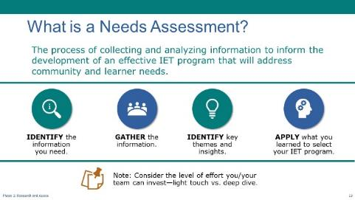

NOTE – Technical Assistant:
- This slide has four builds/clicks (see below).

Present:
- When we talk about a needs assessment, we’re talking about the process of collecting and analyzing information to inform the development of an effective IET program that will address community and learner needs.
- Generally, there are four key activities that comprise a needs assessment for selecting an IET program. These four activities will provide insights into community and learner needs.
- The first activity is identifying the information you need and making a work plan that identifies who you need to talk to and what information you need to gather.
[CLICK TO DISPLAY 2ND ACTIVITY]
- The second activity is gathering the information. There are lots of ways to do this. The toolkit lays out a streamlined process that relies on a few key conversations with partners and learners and reviewing existing information and reports. You may also consider hosting focus groups and a larger set of interviews/conversations if you have more time.
[CLICK TO DISPLAY 3RD ACTIVITY]
- The third activity is processing what you learn from your interviews and research. That means reflecting back on your notes and pulling out key themes and insights. So, for example, you may have gone into this work thinking about doing a healthcare related IET, but in your conversations with the local workforce board staff, and technical college staff, you may realize there’s an unmet need in advanced manufacturing. You may have also found that there is some effort around developing a pre-apprenticeship program that you can capitalize on to create an IET that helps learners transition into an apprenticeship program.
[CLICK TO DISPLAY 2ND ACTIVITY]
- The fourth, or the last, activity is using what you learned to inform the selection of the IET program you’re going to develop.
- Many of you are already using this process in one form or another, and our goal today is to talk more about how you do this and do it in collaboration with partners in your community who can help get you the information you need.
[CLICK TO DISPLAY NOTE]
- Keep in mind that a needs assessment can expand to fit the time and resources you have for it. Every piece of information you gather to inform your IET program selection is valuable. If you have a few days to do this work, good. The IET Toolkit can help you figure out where to focus your effort. If you have longer, the toolkit can help you plan something more robust.
NEXT SLIDE

Five Key Areas of Research
Presenter: [NAME]
Duration: 7 min.

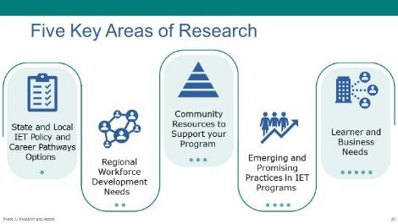
NOTE – Technical Assistant:
- This slide has four builds/clicks (see below).
Present:
- Introduce the five key areas of research for a needs assessment.
- When we think about understanding community needs to inform the development of new IET programs, there are five key areas of research. The Toolkit has a section for each that addresses who to talk to and why and identifies key questions you’ll want to answer. There’s a note taking tool for each key area and a place in the IET Assess Tool for you to capture your key insights.
- In your reading of the Toolkit over the last week, you had a chance to explore these five areas of research, but we want to take a closer look at them today and think about what they may look like in your programs.
- Key Area #1: State and Local IET Policy and Career Pathways Options
If you don’t already have it, you’ll need to gather information about state IET policies and local career pathway activities to ensure that you develop an IET program opportunity that complies with state requirements and aligns with career pathway activities as required under WIOA.
[CLICK TO DISPLAY 2nd KEY AREA]
Key Area #2: Regional Workforce Development Needs
One component of the IET programs is to provide training for learners to acquire the skills needed by employers. When looking for potential IET opportunities, it’s essential to have a sense of which industries and businesses are:
- Hiring
- Paying living wages
- Offering a career pathway
- Challenged to recruit the skilled workers needed to meet industry demand
You don’t need to do this research yourself—there’s no need to analyze labor market information for this. Reach out to partners with labor market analysis experience, such as your local workforce development board or community college, who can provide their insights.
[CLICK TO DISPLAY 3RD KEY AREA]
Key Area #3: Community Resources to Support your Program
You’ll want to identify resources that can support your IET program and the learners who participate, including:
Potential funding sources if that’s not already laid out (like an RFP)
- Training providers
- A network of community organizations to provide supportive services
[CLICK TO DISPLAY 4TH KEY AREA]
Key Area #4: Emerging and Promising Practices in IET Programs
Learn about and get inspired by promising IET program practices from your peers before you decide on possible approaches for your IET program.
This research will help you align your IET program opportunity with best practices and build on the experiences and successes of others.
[CLICK TO DISPLAY 5TH KEY AREA]
Key Area #5: Learner and Business Needs
Learners and the businesses that hire them are key customers of IET programs. To select and design an IET program that responds to customer needs, you’ll need to have a strong understanding of learner goals, challenges, and experiences, and the workforce needs of the business that will hire them. Maybe you’re thinking about targeting a particular population or addressing a particular need in your learner community. Taking some time to listen to learner stories and hear about their experiences and needs can help strengthen your approach.
The same may be true for businesses. Depending on who your training partner or other partners are, you may feel like business needs are already well represented in your future IET work. But if there are gaps, or if you’re part of something new like a specific pre-apprenticeship program, making sure you understand business needs up front helps strengthen your program design.
NEXT SLIDE

Breakout Session: Exploring Key Areas to Assess
Presenter: [NAME]
Duration: 20 min.
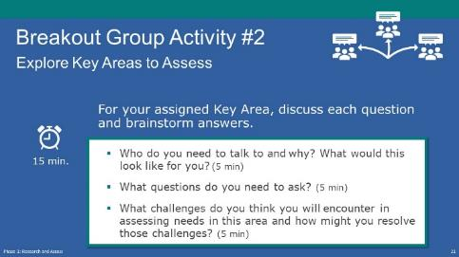
Present: (1 min.)
- Explain the activity.
- Now we’re going to take some time to explore three of these key areas in greater detail. Your breakout group will be assigned one of three key areas: regional workforce development needs, learner and business needs, or community needs.
- For the key area your group is assigned, you’ll think about the three questions on the slide.
[If virtual] Your facilitator will copy these into the chat so you can reference them in your breakout room.
- 1) Who do you need to talk to and why? What would this look like for you? (5 min.)
- 2) What questions do you need to ask? (5 min.)
- 3) What challenges do you think you might encounter in assessing needs in this area and how might you resolve those challenges? (5 min.)
NOTE – Technical Assistant:
- Assign participants to breakout rooms to cover key areas 2, 3, and 5. (Ideally, there will be at least one group for each.)
- Room 1: Key Area #2 - [FACILITATOR(S) NAME(S)]
- Room 2: Key Area #3 - [FACILITATOR(S) NAME(S)]
- Room 3: Key Area #5 - [FACILITATOR(S) NAME(S)]
Breakout Group Activity (15 min.)
FACILITATORS:
- [If virtual]
- Move yourself to your assigned room.
- Copy the Key Area and discussion question into the chat.
- Capture notes as the discussion unfolds. (You may want to share your screen as you take notes.)
- Make sure you have a downloaded version of 1.B1_Research_Assess_Breakout_2_Facilitator_Handout.docx for the activity open. Use the handout to help you guide the discussion and fill in any gaps.
- Focus on your assigned key area as identified in the list above. Note: For the community needs area, be sure to address training providers.
- Spend about 5 minutes per question.
- Who do you need to talk to and why? What would this look like for you?
- What questions do you need to ask?
- What challenges do you think you might encounter in assessing needs and opportunities in this area and how might you resolve those challenges?
Activity Debrief (4 min.):
- As time allows, ask the facilitators of a couple of groups to share some of the notes they have on their key area. Discuss responses as appropriate.
NEXT SLIDE

A Deeper Dive
Presenter: [NAME]
Duration: 1 min.

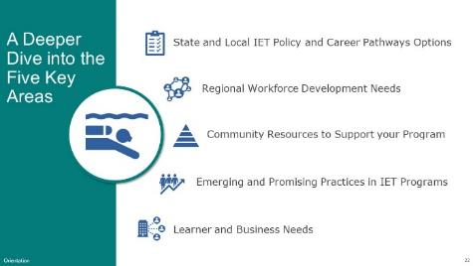
Present:
- Transition from the activity.
- Thank participants for their active participation in the activity.
- Explain that the idea of the activity was to get them to start thinking about the key areas and what they might look like in their local area and what might be involved in engaging with the right people.
- Explain that we’re going to take a deeper dive into each of the five key areas and discuss them further.
- Templates are available to support you as you assess each of these areas as part of the IET Assess Tool in the Toolkit so be sure to check those out.

- Optional homework assignment for upcoming cohort meeting:
- Write a three-sentence “elevator pitch” to the folks you’ll talk to in one of the key areas to get them engaged in an IET program?
NEXT SLIDE

1) State IET Policy and Career Pathways Options
Presenter: [NAME]
Duration: 4 min.
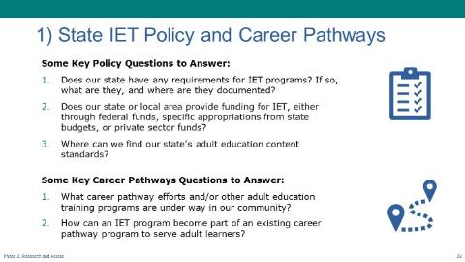
Present:
- Use the PPT slides to walk through state IET policy and career pathways options. Tailor the slide and talking points to your state policy context and priorities.
- The first key area we’ll talk about is assessing state IET policy and career pathways.
- If your state has policies: share requirements and what they mean. Share information on funding specific to IETs as appropriate.
- If your state does not have IET policies: share that there are no specific requirements or funding available.
- All states: discuss where to find adult education standards and any resources or support related to designing courses that meet those standards.
- Review questions about career pathway connections.
- What career pathway efforts and/or other adult education programs are under way in our community?
- Which industry sectors and occupations are the focus of those efforts or programs?
- Which organizations, educational institutions, and businesses are most closely involved in this work? (Are we connected to these entities?)
- How can an IET program become part of an existing career pathway program to serve adult learners?
- Are there specific timelines or processes to follow to connect to these career pathway efforts?
- Ask: Is there anything on this slide that you’re not sure where you’d find this information? If so, please share with the rest of the group and we’ll brainstorm together.
NEXT SLIDE

2) Regional Workforce Development Needs
Presenter: [NAME]
Duration: 4 min.
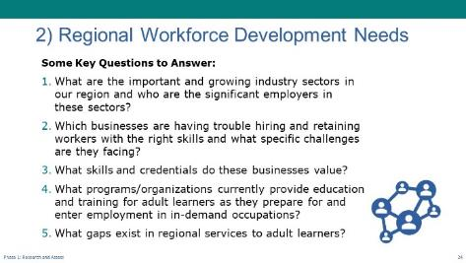
Present:
- Use the PPT slides to walk through regional workforce development needs.
- Next, we’ll focus on Regional Workforce Development needs. Let’s pause to let these questions sink in.
- Ask: Can someone who had this key area in their breakout group share some insights that came out of your discussion? Who did you all identify to help answer these questions? What potential challenges did you identify?
NEXT SLIDE

3a) Community Resources: Training Providers
Presenter: [NAME]
Duration: 4 min. (total)
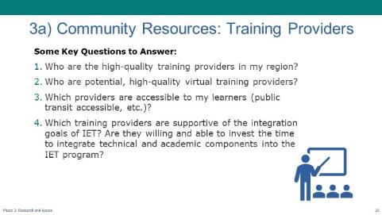
Present:
- Use the PPT slides to walk through community resources to support IET programs.
- Another key area is community resources. This can fall into two types—training providers and organizations that provide funding and/or learner supports.
- A few thoughts on training providers. Although you may already have an established partnership with a training provider, we encourage you to give some thought to the range of potential training provider partners in your community. Not all training providers have high quality programs that are connected to industry standards, industry recognized credentials, or CTE standards, or are able and willing to effectively integrate their training curriculum with the adult education curriculum. You’ll want to work with a training provider who develops their curriculum in close collaboration with local employers; considers existing industry standards; and updates their curriculum regularly to adapt to changing business needs. Don’t forget about the eligible provider list in your state.
- Most community colleges offer CTE programs funded through The Strengthening Career and Technical Education for the 21st Century Act (Perkins V). All Perkins programs offered are required to have advisory boards that provide input into the development of the training curriculum and align the industry standards. This approach results in IET programs that are better able to connect participants to work opportunities upon successful program completion.
- Ask: Can someone who had this key area in their breakout group share some insights that came out of your discussion? Who did you all identify to help answer these questions? What challenges came up?
NEXT SLIDE

3b) Community Resources: Funding and Learner Supports
Presenter: [NAME]
Duration: 2 min. (total)
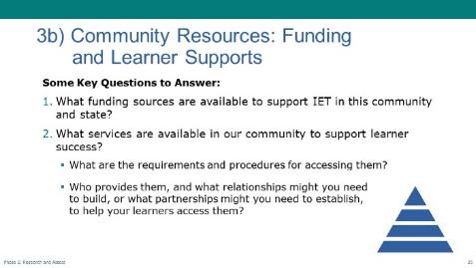
Present:
- Use the PPT slides to walk through community resources for funding and learner supports. Tailor the slide and talking points if there are any unique resources available in your state.
- It’s also important to identify and understand organizations that provide funding and/or Learner supports in your community. These may include community and faith-based non-profits, foundations, local branches of national organizations, etc.
- Again, on the slide are some questions to get you started.
NEXT SLIDE

4) Emerging and Promising Practices in IET Programs
Presenter: [NAME]
Duration: 2 min. (total)
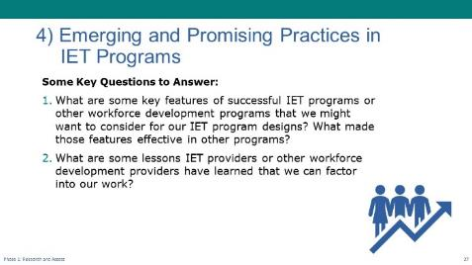
Present:
- Use the PPT slides to walk through some questions to ask to leverage emerging and promising practices in IET programs.
- Learning from others is so important. The toolkit offers some thoughts about how to identify programs to learn from. What models inspire you? Where are you seeking promising practice inspiration?
NEXT SLIDE

5) Learner and Business Needs
Presenter: [NAME]
Duration: 5 min.
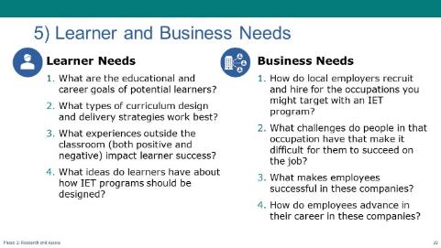
Present:
- Use the PPT slides to walk through some questions to ask to identify learner and business needs.
- The last key area is Learner and Business needs. As the primary customers of your IET program, learners and employers play critical roles in the program’s success. We’ll spend more time talking about this in the next phase: Design and Plan, but for now, the key takeaway is how important it is to put these customers at the center of your assessment and design work.
- Again, there is a place in the IET Assess Tool to capture ideas/thoughts as you think about and discuss the needs of learners and businesses.
- The questions on the screen will get you started.
- Ask: Can someone who had this key area in their breakout group share some insights that came out of your discussion? Who did you all identify to help answer these questions? What potential challenges did you identify?
NEXT SLIDE

Questions? (Plan and Conduct a Needs Assessment)
Presenter: [NAME]
Duration: 4 min.

Present:
- Ask if there are any questions about planning and conducting a needs assessment to inform your IET program selection.
NEXT SLIDE

1-3 Identify Insights and Brainstorm Solutions
Estimated Start Time: [ENTER TIME]

Identify Insights and Brainstorm Solutions – Topic Introduction
Presenter: [NAME]
Duration: 1 min.
Present:
- Introduce the topic and subtopics.
- In our last segment for today, we’re going to talk about what to do with all the information you gathered in your needs assessment.
- What insights did you discover?
- What new questions were raised?
- How to start bringing it together to select an IET program that meets your community’s needs.
NEXT SLIDE

Synthesize Needs Assessment Data
Presenter: [NAME]
Duration: 2 min
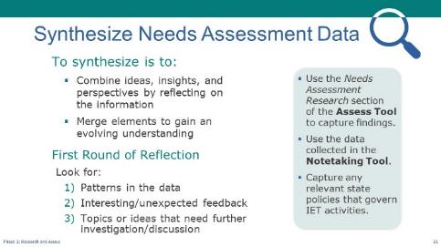
NOTE – Technical Assistant:
- This slide has one build/click (see below).
Present:
- Explain the process for synthesizing information from the needs assessment and identifying insights during the first round of reflection. Tailor the talking points to reflect whether there are state IET requirements to consider.
- Once your team has completed your needs assessment, it’s time to start synthesizing and analyzing the information so that you can select an effective IET program that meets the community’s needs.
- Synthesizing involves combining ideas, insights, and perspectives by reflecting on the information gathered and merging elements to gain an evolving understanding.
- You can use the Needs Assessment Research section of the Assess Tool, which organizes the information by the five key areas, to capture your key findings. You’ll use the data you collected in the Notetaking Tool to do this work. Be sure to also capture any state policies that govern IET activities, if relevant.
- [CLICK TO BUILD SLIDE]
- First Round of Reflection
- Start by identifying insights that paint a picture of the needs and opportunities in your community. You can organize your insights into categories such as:
- Patterns in the data - What patterns exist in the research and stakeholder feedback related to unmet workforce and learner needs that an IET program might address?
- Interesting/unexpected feedback - What did you find interesting or unexpected, yet significant in the feedback? Were any of your incoming assumptions challenged to discover surprising needs or opportunities? Include any “aha moments” or what you felt was most surprising.
- Needs further investigation - What do you want to discuss more with the design team? This might come during your discussions with the group as you begin to synthesize your information. Remember, this work is iterative, so you may find that more data is needed before you can select an IET program that is desirable, feasible, and viable.
NEXT SLIDE

Second Round of Reflection: Reflecting with Partners
Presenter: [NAME]
Duration: 3 min.
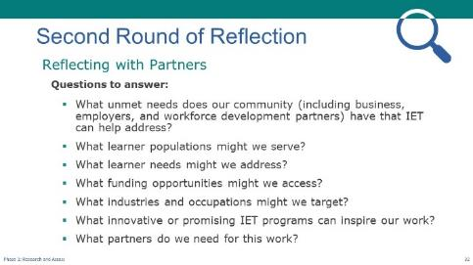
Present:
- Review some questions to reflect on during the second round of reflection.
- With your needs assessment information organized and insights documented, the next step is to pull together training partners you’re working with and other key stakeholders to start adding some details and give some thought to the broader list of questions we shared earlier in our presentation. Ultimately, you want to answer these questions:
- What unmet needs does our community, including business, employers, and workforce development partners, have that IET can help address?
- What learner populations might we serve through an IET program?
- What learner needs might we address through the IET program design?
- What funding opportunities might we access?
- What industries and occupations might we target?
- What innovative or promising IET practices did we learn about that might benefit our community?
- What partners do we need for this work?
- Once you’ve pulled out these insights and answered these questions, you’re ready to brainstorm solutions, which we’ll briefly touch on next.
NEXT SLIDE

Brainstorm Solutions and Select an IET
Presenter: [NAME]
Duration: 2 min.
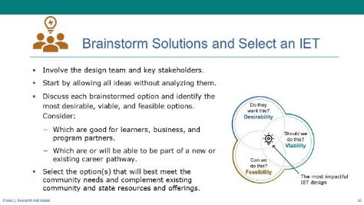
NOTE – IET Training Team:
- If you are not doing cohorts, remove the last part of the last sub-bullet below.
Present:
- Discuss tips for brainstorming and selecting an IET program.
- Waiting until now to brainstorm solutions lets you really center the needs of your community. Most of us are constantly in problem solving or solution development mode. But if you stay curious while you’re gathering information and wait until this stage of the process to brainstorm IET programs that respond to community needs, you’ll have a full picture, and will be well-positioned to select a program that is desirable, feasible, and viable, like we talked about earlier.
- Let’s talk about some tips for this activity.
- You’ll find that involving the design team and key stakeholders in the brainstorming process will help you get a wide variety of perspectives as each person will interpret the needs assessment findings from their own perspective. Keep this group to a manageable number of people so that you can make meaningful progress.
- Start by allowing all ideas without trying to analyze them or eliminate them off-hand. The more ideas, the better at this point. Ideas will feed upon each other, and you may come up with some surprising and innovative ideas.
- Once you’ve developed a good list of options, go through the list and remove duplicate or combine similar ideas, then brainstorm each option to identify the most desirable, viable, and feasible options. Remember, this is where the most impactful IET design is identified. Think about:
Is this good for learners and business and other program partners?
Is it or will it be able to be part of a new or existing career pathway?
- Finally, select the option or options that will best meet the identified community needs and complement existing community and state resources and offerings.
- Again, the Toolkit has information and resources to support you through this process, and we’ll take a much deeper dive in the cohort focused on this topic.
NEXT SLIDE

Questions? (Identify Insights and Brainstorm Solutions)
Presenter: [NAME]
Duration: 4 min.
Present:
- Ask if there are any questions about synthesizing the needs assessment to select an IET program to meet community needs.
- Respond to questions.
NEXT SLIDE

1-4 Wrap-Up
Estimated Start Time: [ENTER TIME]

Wrap-Up - Topic Intro
Presenter: [NAME]
Duration: 1 min.
Present:
- Explain that we will wrap up the session by:
- Reviewing some key takeaways
- Reflecting on what you learned, what stood out to you, and what questions you may have.
- Conducting a quick poll
- Going over next steps
NEXT SLIDE

Three Key Takeaways
Presenter: [NAME]
Duration: 2 min.
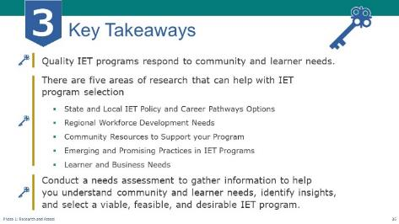

NOTE – Technical Assistant:
- This slide has 2 builds/clicks to display the key takeaways one a time as the facilitator discusses each (see below).
Present:
- Review key takeaways from this session.
- Quality IET programs respond to the needs of adult learners, the community, businesses, workforce development, and program partners.
- Understanding community needs means gathering information and insights from a range of stakeholders in the five key areas we discussed.
- Conduct a needs assessment to gather information to help you understand community and learner needs, identify insights, and select a viable, feasible, and desirable IET program.
- You don’t have to do this work alone – you can build on the work of partners like the workforce development system. The Toolkit includes some useful links that can help you in the Research and Assess phase, so be sure to check those out.
NEXT SLIDE

Group Discussion – Reflection on Today’s Topic
Presenter: [NAME]
Duration: 10 min.
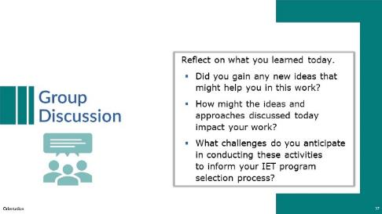
NOTE – IET Training Team:
- This discussion can be conducted with the whole group of participants, or you may choose to conduct it in breakout groups and then ask groups to share one or two things they came up with.
Discuss:
- Lead a group discussion reflecting on what was covered in this training session.
Possible questions:
- Did you gain any innovative ideas that might help you in this work?
- How might the ideas and approaches discussed today impact your work?
- What challenges do you anticipate in conducting these activities to inform your IET program selection process?
- As time allows, ask if there are any lingering questions about what was covered in this session—whether about the value of understanding community needs and conducting a needs assessment or selecting an IET program to develop.
NEXT SLIDE

Poll: Relevance (Optional)
Presenter: [NAME]
Duration: 2 min.
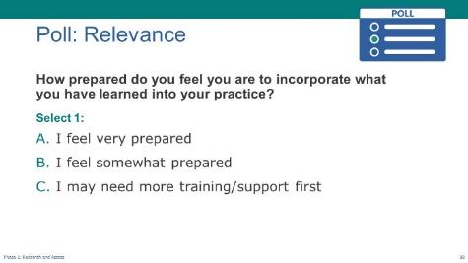
NOTE – IET Training Team:
- This is an optional poll. You can choose to delete or modify it as needed. Remember to do the same in the slide deck.
Poll:
- Introduce the poll question and ask participants to respond.
- Take a quick minute to let us know how prepared you feel to incorporate what you’ve learned in today’s session into your practice.
- I feel very prepared.
- I feel somewhat prepared.
- I may need more training/support first.
- If in-person] Read the options and have participants raise their hands (“Raise your hand if you feel very prepared.” “Who feels somewhat prepared?” “Raise your hand if you feel you may need more training or support first?”).
- [If virtual] Ask technical assistant to launch poll and give participants a little time to respond, then share the results.

- Respond to the results
NEXT SLIDE

Next Steps
Presenter: [NAME]
Duration: 2 min.
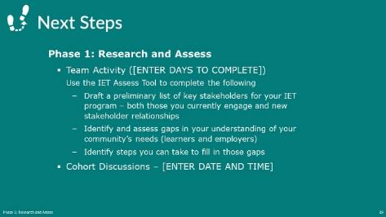
NOTE – IET Training Team:
- Modify this slide and the next to fit your structure and schedule. For example, add dates and times where indicated. If you are not doing cohorts, remove the last bullet on this slide.
Present:
- Use the PPT slide to talk through the team activity and the next cohort meeting (if applicable).
NEXT SLIDE

Next Steps (cont.)
Presenter: [NAME]
Duration: 1 min.
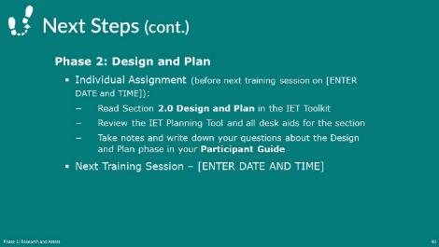

NOTE – IET Training Team:
- Modify this slide and the next to fit your structure and schedule. Add dates and times where indicated.
Present:
- Explain the individual assignment to do before the next session and restate the date and time of the next session.
- Thank everyone for their participation and end session.

After the Session

Follow-Up Recommendations
- Send an email to check in with participants before the next training session.
- Remind them of the homework assignment, the date and time of the cohort meeting (if applicable), and the date and time of the next Design Camp training session.
- Suggest that participants review the Design and Plan section of the IET Toolkit and download and review the IET Planning Tool.
- Remind participants to write down any questions they have in their Participant Guide as they review the Design and Plan section of the IET Toolkit.

