Facilitator Guide for
PHASE 2: DESIGN AND PLAN

Facilitator Guide for IET Design Camp
Phase 2 – Design and Plan

Introduction
Welcome to the Facilitator Guide for the virtual or in-person delivery of the IET Design Camp, Phase 2: Design and Plan. This guide outlines everything you need to know to facilitate the training, including session logistics, training materials, learning objectives, timing, and talking points for each slide. Training teams should a) review this guide and the corresponding training materials (see below) and b) make modifications based on who is delivering the training, when s/he will deliver the training, and how s/he will deliver the training.

Logistics
Session Date: [ENTER DATE]
Session Time: [ENTER TIME AND TIME ZONE]
Estimated Run Time: 2 hours [EDIT ESTIMATED TIME AFTER CUSTOMIZING SLIDES]
Technical Assistant: [ENTER TECHNICAL ASSISTANT NAME]
Session Moderator(s): [ENTER MODERATOR NAME(S)]
Trainers/Facilitators: [ENTER TRAINER/FACILITATOR NAME(S)]

Overview
Building on the concepts covered in the previous session, which focused on Phase 1: Research and Assess, this training session will introduce participants to the process for designing an Integrated Education Training (IET) program, which begins with defining program-level goals. Participants will learn about the elements of program structure and the four stages of the learner experience. In addition, they will explore what makes a successful IET program and consider the types of learner supports needed to help boost learner motivation, persistence, and success in the IET program and into employment or further education. Finally, trainers will briefly touch on the importance of embedding evaluation into their planning to support continuous improvement and sustainability efforts.

Training Materials
- PowerPoint Deck: 2.A2_Design_Plan_PPT.pptx
- Participant Guide: Participant_Guide.docx
- Breakout Group Activity Files:
- (In-Person and Virtual)
- 2.B1_Design_Plan_Breakout_ 1_Facilitator_Guide.docx
- 2.B3_Design_Plan_Breakout_2_Facilitator_Guide.docx
- (Virtual Only)
- 2.B2_Design_Plan_Breakout_1_Facilitator_PPT_Virtual.pptx
- 2.B4_Design_Plan_Breakout_2_Facilitator_PPT_Virtual.pptx
Toolkit Sections Covered in this Session

- Design and Plan
- 2.1 Getting Started
- 2.2 Design the Program Structure
- 2.4 Design the Learner Experience
- Desk Aids
- IET Assess Tool
- IET Planning Tool
- Evaluation Plan Template

Objectives
After completing this session, participants will be able to:
- Explain the purpose of the IET Planning Tool for designing an IET program.
- Define the IET program-level goals and determine the instructional approach.
- Use a series of tools and steps to design an IET program structure.
- Identify ways to incorporate college and career planning into the curricula.
- Identify ways to promote digital literacy.
- Plan the learner experience and the support learners will receive.

2-0 Overview/Introduction
Start Time: [ENTER TIME]

Welcome and Overview of the Training Session
Presenter: [NAME]
Duration: 1 min.
Present:
- Welcome participants to the session.
- Introduce yourself and provide a brief overview of the session.
This session will build on the key tasks and concepts from Phase 1: Research and Assess and will introduce the process for designing an IET program.
- NEXT SLIDE

Virtual Meeting Recording Notice (OPTIONAL)
Presenter: [NAME]
Duration: .5 min.
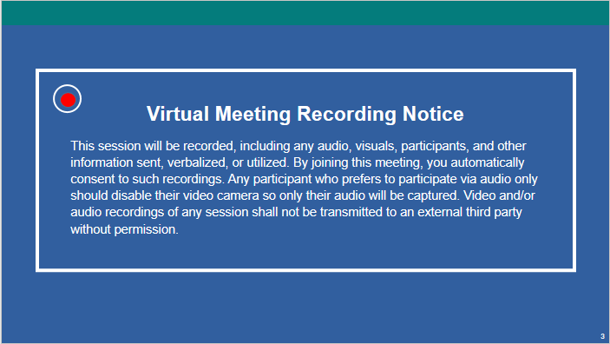
NOTE – IET Design Team:
- This is an optional slide. If you are delivering the training in person or do not need a recording notice, delete this slide from the PowerPoint slide deck and from this Facilitator Guide.
Present:
- Remind participants that this session will be recorded and direct them to the disclosure on the slide.
- NEXT SLIDE

Virtual Classroom Reminders (Optional)
Presenter: [NAME]
Time: .5 min.
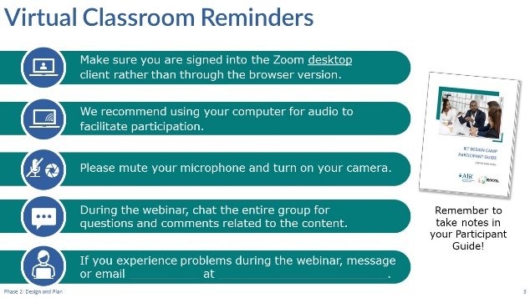
NOTE – IET Training Team:
- This is an optional slide. If you are delivering the training in person, delete this slide from the PowerPoint slide deck and from this Facilitator Guide. If you are delivering the training in another platform, edit this slide accordingly.
Present:
- Review virtual classroom reminders.
- Please take a moment to read through these reminders and make sure you’re ready to participate in the session.
- You may want to open your Participant Guide to take notes or refer to any questions you had during your Toolkit reading assignment.
- NEXT SLIDE

Agenda
Presenter: [NAME]
Duration: 1 min.
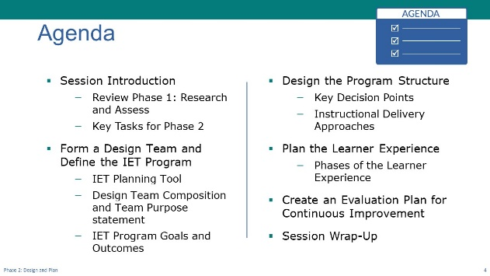
Present:
- Review the agenda
- We’ll start today by briefly reviewing some key tasks and concepts for Phase 1, Research and Assess.
- Next, we’ll talk about forming a design team and defining the IET program goals and structure. For this we’ll look in more detail at the IET Planning Tool provided in the Toolkit. You’ll see how comprehensive this tool is for guiding you through designing and developing your IET program.
- Then we’ll look at designing the program structure—some key decision points and determining the instructional delivery approach you’ll use for your program.
- Next, we’ll discuss the four stages of the learner experience, and you’ll have an opportunity here to consider the learner experience through the eyes of a potential learner.
- Finally, we’ll briefly explore the importance of creating an evaluation plan for your program. You’ll create the evaluation plan in this phase—The Design and Plan phase—but Phase 4: Evaluate and Improve is when you’ll actually evaluate the program. We’ll talk more about evaluation during that training session
- As always, we’ll wrap up with key takeaways and next steps.
- NEXT SLIDE

Today’s Trainers
Presenter: [NAME]
Duration: .5 min.
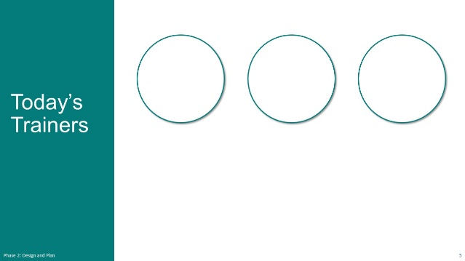
Present:
- Introduce the trainers or have them introduce themselves.
- NEXT SLIDE

IET Design Camp – We are Here
Presenter: [NAME]
Duration: 1 min.
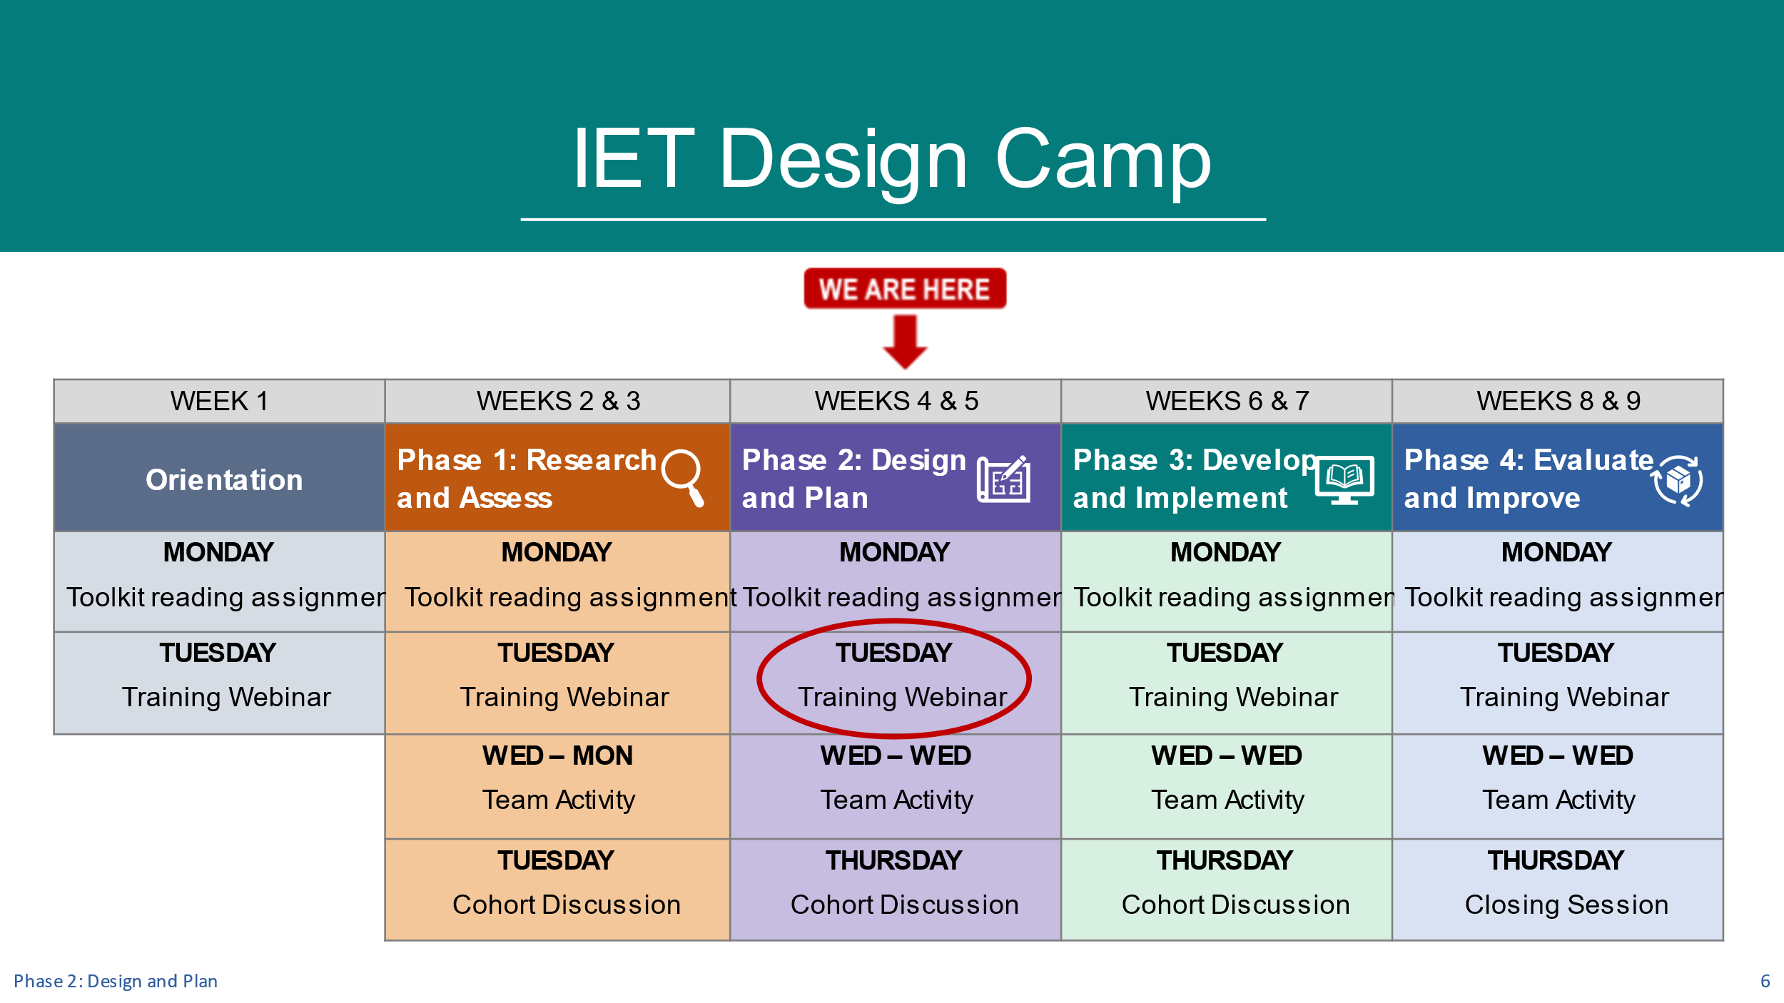
NOTE – IET Training Team:
- You should have already developed a table that reflects the structure and organization of your Design Camp for the Orientation session. You may want to copy and paste your table onto this slide and move the “WE ARE HERE” and arrow to the Phase 2 session. You may want to circle the activity you are on (Training Session).
- If you are not doing team activities and/or cohorts, modify or remove the second sub-bullet below.
Present:
- Orient participants to where you are in the Design Camp—Phase 2. Tailor your talking points to reflect the design and schedule of your training (e.g., you may not be doing a cohort meeting.)
- Today we’re in Phase 2: Design and Plan. Hopefully you’ve had a chance to read the Design and Plan section in the IET Toolkit over the last week and explored the IET Planning Tool.
- As a reminder, after today’s training session, you’ll have a little time to do your team activity, and we’ll meet again next [ENTER DATE], for your next cohort meeting (if applicable).
- Let’s get started.
- NEXT SLIDE

Review of Phase 1: Research and Assess
Presenter: [NAME]
Duration: 1 min.
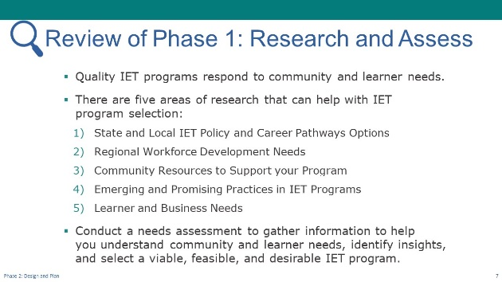
Present:
- Provide a quick review of Phase 1: Research and Assess.
- Before we jump into the content for today, we wanted to briefly review key concepts from Phase 1: Research and Assess.
- In our last training session, we focused on the importance of responding to community AND learner needs when implementing IET and we heard how you all gather information yourselves or lean on partners to learn more.
- We talked about the benefit of intentionally sitting back and just “listening” to stakeholders before embracing the first opportunity that surfaces. This listening and reflecting time may bring insights that could be overlooked if not carefully thought through.
- We also spent a good chunk of time, including time in small groups, discussing the five areas of research shown on the slide.
- Although these areas of research may seem daunting to some of you as you struggle to accomplish everything that’s expected of you in your jobs, we hope you walked away with an understanding that IET is all about “connecting” and leveraging the strengths of others who complement your goal of providing “real” opportunities for adult learners to enter career pathways that set them up for long-term success.
- As we transition to today’s content, we’re going to continue talking about partners and the role they can play as you plan the design of your IET program, including helping to set your program goals. We’ll spend some time thinking through key considerations for your program’s structure, planning for the learner experience, and selecting an instructional delivery approach.
- NEXT SLIDE

Key Tasks for Design and Plan Phase
Presenter: [NAME]
Duration: 1 min.
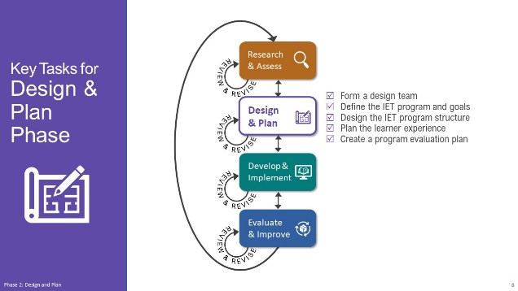
Present:
- Briefly review the key tasks for the Design and Plan phase:
- Form a design team
- Define the IET program and goals
- Design the IET program structure
- Plan the learner experience
- Create a program evaluation plan
- Explain that we’re going to touch on all of these at least briefly, but our focus will be on forming a team and defining the IET program and goals, designing the program structure, particularly determining the instructional delivery approach, and planning the learner experience.
- NEXT SLIDE

Group Discussion – Reflect on Your Reading
Presenter: [NAME]
Duration: 4 min.
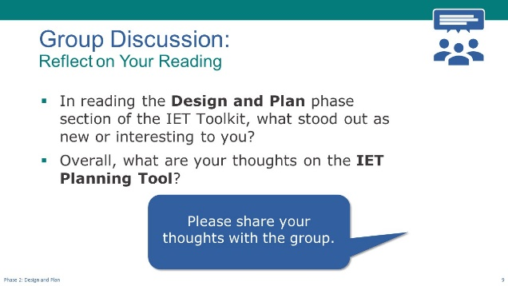
Discuss/Chat:
- Facilitate a discussion on the following question(s).
- In reading the Design and Plan phase section of the IET Toolkit, what stood out as new or interesting to you?
- Overall, what are your thoughts on the IET Planning Tool?
- [If In-Person] Ask participants raise their hand or call out responses.
- [If Virtual] Have participants share responses in the chat or unmute their microphone to speak.
- NEXT SLIDE

Poll: IET Involvement (Optional)
Presenter: [NAME]
Duration: 2 min.
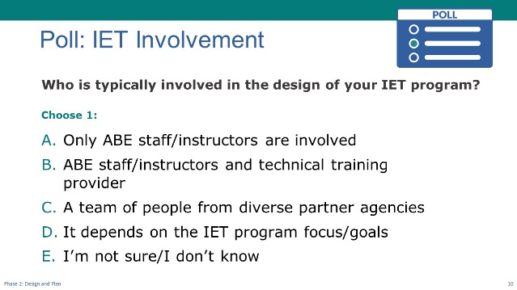
NOTE – IET Training Team:
- This is an optional poll designed to engage participants in the content for this session. You can delete or modify it as needed and adjust the time spent on discussion results according to your priorities.
Poll:
- Introduce the poll question and ask participants to respond.
- [If In-Person] Read the options and have participants raise their hands.
- [If Virtual] Ask the technical assistant to launch poll and give participants a little time to respond, then ask technical assistant to share the results.
- Discuss responses
- NEXT SLIDE

2-1 Form a Team and Define the IET Program and Goals
Start Time: [ENTER TIME]

Form a Team and Define the IET Program and Goals – Topic Intro
Presenter: [NAME]
Duration: 1 min.
Present:
- Introduce the topic and subtopics.
- As we discussed in our last session, the information you gather from community stakeholders and learners during the Research and Assess phase will inform key decisions such as what industry and occupation the IET will focus on and how to best serve the targeted population. Once you’ve made those key decisions, it’s time to roll up your sleeves and do program design and planning work.
- You’ve already begun digging into the IET Toolkit and a few supporting resources to use as you engage in this work. Similar to the Assess tool that was created for the research and needs assessment work, the IET Planning Tool provides a structure to capture and organize your design and development work. We will reference both the Toolkit and the Planning Tool as we move through content today.
- Let’s get started by taking a closer look at the IET Planning Tool.
- NEXT SLIDE

IET Planning Tool
Presenter: [NAME]
Duration: 2 min.
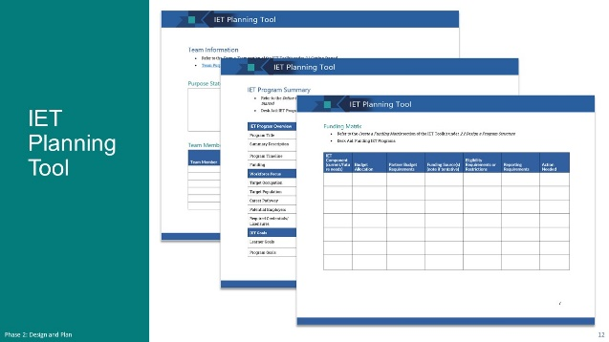
NOTE – Technical Assistant:
- This slide has two builds (clicks) to display screenshots one at a time as the facilitator reviews each.
Present (1 min):
- Briefly review the IET Planning Tool.
- One of the key desk aids in the IET Toolkit is the IET Planning Tool. We went over it briefly in the Orientation, but I wanted to remind you of it today. You can use this tool to guide your design and development efforts and keep track of key information about your IET program.
- The first section provides an area for you to document your team purpose statement and your design team members’ names, organization, relevant skills, and resources they bring to the table and their contact information.
- [CLICK TO DISPLAY NEXT SCREENSHOT]
- In another section, you’ll capture some of the key program information, such as an overview of the program, the workforce focus, and your high-level goals for the program, as well as for the learners and partners.
- [CLICK TO DISPLAY NEXT SCREENSHOT]
- You’ll also see tools for capturing your funding sources, a communication plan, and other useful tools. We’ll be discussing some of these elements throughout the session today but be sure to check it out if you haven’t already. I think you’ll find it very useful.
- NEXT SLIDE

Design Team Composition
Presenter: [NAME]
Duration: 4 min.
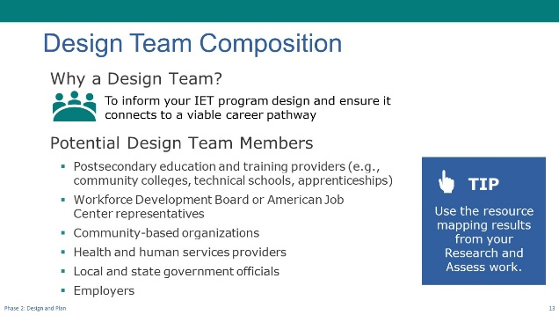
Present:
- Use PPT slide to briefly discuss the value of a design team and who might be considered for the team.
- Reference the poll results from earlier, e.g., “How many use a small team or are going solo when designing?” or, “I was encouraged by…”
- Why a design team? Because as we all know, two heads are better than one, three heads are better than two, and so on. A design team brings innovation that can inform the IET design and ensuring it meets business and learner needs and connects to a viable career pathway.
- Of course, we all come from different places so the structure and resources of your program and community are different. At a minimum this work may be done primarily by Adult Basic Education (ABE) staff and staff who deliver occupational skills training. Ideally, the team should include other partners who can provide diverse perspectives that inform your IET program design, ensure it connects to a viable career pathway, and provide any additional supports learners may need to participate in the program.
- In addition, whoever is doing the work should be able to make decisions regarding the program structure, necessary learner supports, and the integrated curriculum. The Toolkit includes a resource mapping activity in the Research and Assess phase that can be used as you consider inviting potential team members or seek input from partners understand cultural differences and who have resources and supports for adult learners. This slide includes a few that you might consider:
- Postsecondary education and training providers (e.g., community colleges, technical schools, apprenticeships, etc.)
- Workforce Development Board or American Job Center representatives
- Community-based organizations
- Health and Human Services providers
- Employers
- NOTE: If you’re not able to engage with employers directly, ensure that you have access to at least one stakeholder who can provide an employer perspective.
- Remember, personalities matter in teams. Before inviting team members, consider if they will actively participate, respect the opinions of others, collaborate, and think creatively across disciplines, consult with a solutions-oriented mindset, and make informed decisions. Move beyond the usual “go-to” people to consider colleagues who have different roles and hierarchical levels; diverse backgrounds, cultural and ethnic experiences; levels of expertise; and disciplines. An often overlooked yet important step in recruiting members is to develop a team purpose statement.
- NEXT SLIDE

Team Purpose Statement
Presenter: [NAME]
Duration: 2 min.
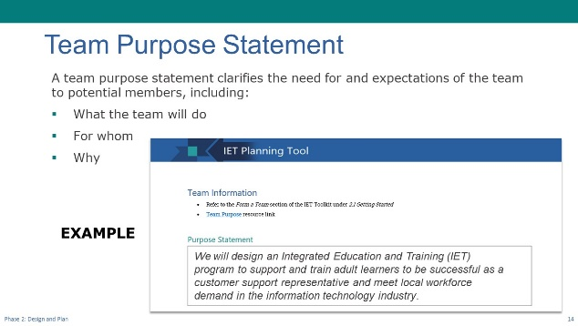
NOTE – Technical Assistant:
- This slide has one build (click) to display an example team purpose statement (see below).
Present:
- Explain what a team purpose statement is and what it includes.
- A team purpose statement clarifies the need for and expectations of the team to potential members. A good statement identifies:
- Why we need an IET design team.
- What the team will focus on.
- Who the team serves and why.
- [CLICK TO SHOW EXAMPLE]
- Read the sample statement.
- We will design an Integrated Education and Training (IET) program to support and train adult learners to be successful as a customer support representative and meet local workforce demand in the information technology industry.
- Don’t underestimate the value of a team purpose statement. It’s very useful for ensuring that everyone has the same expectations for why they are spending valuable time doing this work.
- NEXT SLIDE

IET Goals and Outcomes: SMART Goals
Presenter: [NAME]
Duration: 1 min.
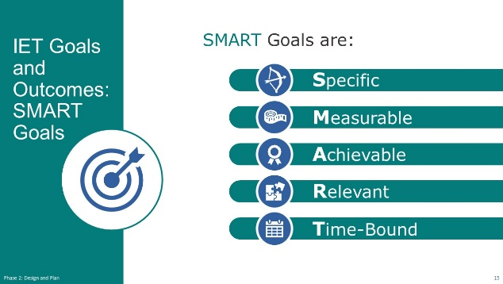
Present:
- Review the SMART Goals format for creating effective goals.
- One of the most important things you’ll do during the Design and Plan phase is to develop measurable goals for your IET program. Your goals should clearly define what you plan to achieve for learners and partners through your program. As you continue through this phase, your goals will guide your design.
- You’ll probably recognize the SMART Goal format, as it’s one that we commonly use in helping learners establish their goals.
- SMART goals are:
- Specific – Does the goal clearly state what will be done and who will do it so that anyone reading it can understand?
- Measurable – Does it include a description of how the action will be measured so you know if you’ve met the goal?
- Achievable – Is it realistic given the realities faced in the community?
- Relevant – Does it make sense? In other words, does it fill a need and fit the culture and structure of the community?
- Time-bound – Does it include a specific timeline for completion so you have a target for when it will be done?
- NEXT SLIDE

Three Types of IET Goals
Presenter: [NAME]
Duration: 1 min.
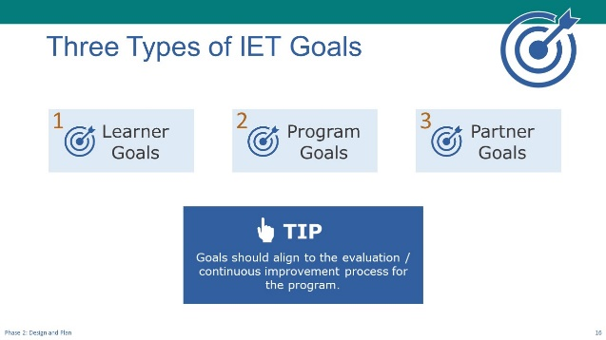
Present:
- Introduce the three types of IET goals.
- There are three types of IET goals: learner goals, program goals, and partner goals. These goals are high-level goals that define what you plan to accomplish through the IET program.
- We’re going to look at examples of each type.
- Goals should connect to evaluation/continuous improvement efforts, which we’ll talk more about later and then in more detail in our last training session.
- NEXT SLIDE

Types of IET Goals: Learner Goals
Presenter: [NAME]
Duration: 2 min.
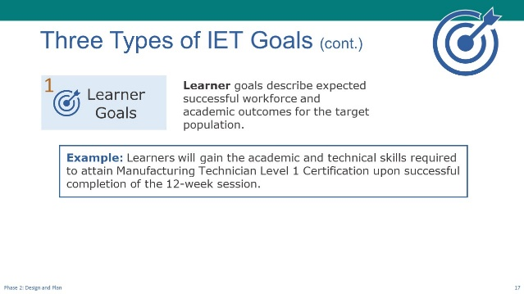
Present:
- Describe learner goals.
Learner goals are goals that describe expected, successful workforce and academic outcomes for the IET program’s target population.
- These learner goals are overarching goals for all learners who go through the IET program, not the individual learner goals that are developed during intake, which will be specific to individual learners.
- Review the example learner goal:
Example: Learners will gain the academic and technical skills required to attain Manufacturing Technician Level 1 Certification upon successful completion of the 12-week session.
- Notice that this goal:
- Specifically states what the learner will do—gain the academic and technical skills.
- Includes how it will be measured—they’ll attain Manufacturing Technician Level 1 Certification.
- It appears to be achievable and relevant to the learner.
And it has an associated timeline—upon completion of the 12-week session.
We’ll talk about the learner experience later in this session.
- NEXT SLIDE

Types of IET Goals: Program Goals
Presenter: [NAME]
Duration: 3 min.
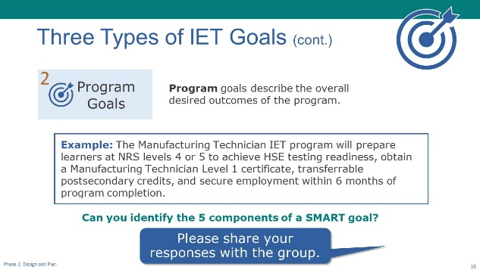
Present (1 min.):
- Explain program goals:
- Program goals describe the overall desired outcomes of the program.
- Here’s an example of an effective program goal:
The Manufacturing Technician IET program will prepare learners at NRS levels 4 or 5 to achieve HSE testing readiness, obtain a Manufacturing Technician Level 1 certificate, transferrable postsecondary credits, and secure employment within 6 months of program completion.
Discuss (2 min.):
- Facilitate a discussion about whether this goal includes the five components of a SMART goal.
- Looking at this goal, see if you can identify the five components of the SMART Goals. [If virtual] Put your answers in the chat.
- Look for:
- Specific – clearly states, so anyone reading it can understand, what will be done and who will do it.
- Measurable – includes how the action will be measured. [HSE testing readiness, obtain Manufacturing Technician Level 1 certificate, secure employment]
- Achievable – is realistic given the realities faced in the community. [It looks like it’s reasonable to expect that this is achievable.]
- Relevant – makes sense, that is, it fills a need and fits the culture and structure of the community [assuming that a comprehensive needs assessment was conducted and that it identified the need for skilled manufacturing technicians and the relevant certificates needed to fill local employment opportunities, this appears to be relevant].
- Time-bound – has a specific timeline for completion [within 6 months of program completion].
- NEXT SLIDE

Three Types of IET Goals: Partner Goals
Presenter: [NAME]
Duration: 3 min.
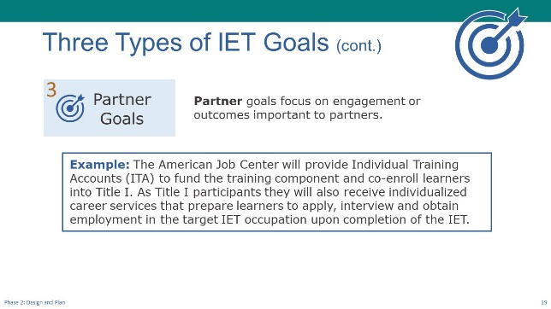
Present:
- Describe partner goals.
- Partner goals are goals that focus on engagement or outcomes important to partners.
- Read the example partner goal.
- Each term, the American Job Center will provide Individual Training Accounts (ITA) to fund the training component and co-enroll learners into Title I, where they will also receive individualized career services that prepare learners to apply, interview and obtain employment in the target IET occupation upon completion of the IET.
- Reference the relevant resources in the Toolkit.
- There are additional resources in the Toolkit. You can capture your goals in the IET Program Summary section of the IET Planning Tool.
- For more information and examples, check out Desk Aid 6: IET Program Goals and Outcomes.
- Ask if there are any questions about the three types of IET goals.
- NEXT SLIDE

Breakout Group Activity #1: What does a successful IET program look like?
Presenter: [NAME]
Duration: 22 min. (total)
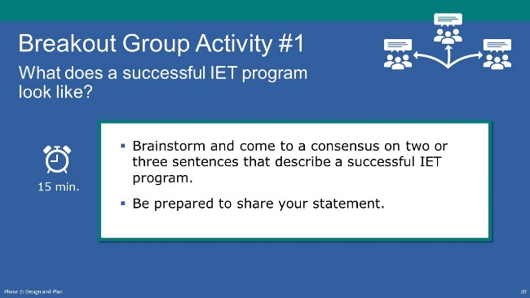
NOTE – IET Training Team:
- If you are conducting the training virtually, you will need to have the technical assistant set up breakout rooms and assign participants and group facilitators to a room (See tech note below).
Present: (1 min.)
- Explain the activity.
- Once you have your design team in place and have created a team purpose statement to make sure everyone is on the same page, you’ll want to begin thinking about what success looks like for your IET program.
- We all have the common goal of creating an IET program that is successful.
- For this activity we’d like you to brainstorm what you feel a successful IET program looks like. By the end of your breakout time, come to a consensus on two or three sentences that describe a successful program.
- Each group will have a facilitator to guide the discussion and capture notes.
- You’ll have about 15 minutes to come up with your statements and then we’ll come back together to share our success statements and key insights from the conversation.
NOTE – Technical Assistant:
- Assign participants to breakout rooms as needed:
- Room 1- [FACILITATOR(S) NAME(S)
- Room 2- [FACILITATOR(S) NAME(S)
- Room 3- [FACILITATOR(S) NAME(S)
Breakout Group Activity: (15 min.)
- If in person: Use 2.B1_Design_Plan_Breakout_1_Facilitator_Guide.docx to capture your group’s key words and success statements. Alternatively, you may also want to start with a large blank paper and have the group write down their own key words as a brainstorming activity. They can connect to other key words as they spark ideas. Then use the words on that sheet to develop the success statements.
- If virtual: Facilitators, instructions for facilitating this activity are in 2.B1_Design_Plan_Breakout_1_Facilitator_Guide.docx. Open the PowerPoint file, 2.B2_Design_Plan_Breakout_1_Facilitator_PPT_Virtual.pptx and share your screen. Capture your group’s key words and success statements directly on the slide.
Activity Debrief (6 min.)
- Call on a few group facilitators to share insights from the discussion. [If virtual] Have facilitators copy and paste their group’s success statement(s) into the chat window once back on the main room.
- Lead a discussion about any highlights or surprises from the activity.
- Close the discussion with a few reminders.
- Program success depends on having a structure that’s supported by available funding, strong partnerships, and effective program policies, and includes learner supports. The program structure should allow your IET program to be nimble enough to adapt to changes in funding, key program staff, and workforce needs.
- As you explore the Toolkit, you’ll see that the Design and Plan portion touches on each of these areas. In addition, the IET Planning Tool provides an organized structure to capture key decisions and next steps as you transition toward implementing your program.
- NEXT SLIDE

2-2 Design a Sustainable IET Program Structure
Start Time: [ENTER TIME]

Design a Sustainable IET Program Structure – Topic Intro
Presenter: [NAME]
Duration: 1 min.
Present:
- Introduce the topic and subtopics.
- IET programs require an integrated curriculum in which basic skills and workforce preparation are contextualized to the occupational training. This integration requires intentional collaboration in developing the learning objectives across the program curricula during curriculum development, aligning them to the program-level goals, and thoughtfully planning how the instruction will be delivered.
- In this topic, we’ll talk about some key decision points when designing an IET program.
- We’ll also look at four common instructional delivery approaches.
- Next, we’ll share some best practices to consider for virtual delivery of IET instruction.
- Finally, we’ll explore some resources for providing digital supports beyond the classroom.
- NEXT SLIDE

Key Decision Points
Presenter: [NAME]
Duration: 1 min.
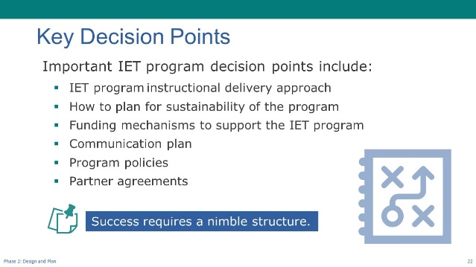
Present:
- Discuss key decision points related to the program structure.
- Some important IET program decision points related to designing the program structure include:
- The instructional delivery approach for your program. How will you structure your instruction time so that the teaching is collaborative and integrated?
- Key drivers for the sustainability of the program, such as appropriate partnerships, committed staff and leadership, and a clearly-defined process of evaluations and continuous improvement.
- The necessary funding mechanisms to support and sustain the program you’re planning. Review Section 1.1, page 12 and page 20 and Section 2.2 in the Toolkit. The Assessment Tool will also help you plan for a sustainable program by asking key questions.
- An effective communication plan is essential so that everyone is informed at every step. There is a communication plan template in the IET Planning Tool.
- How will you ensure that everyone understands the program policies and how to access them? You’ll want to create a documented set of program policies so that all parties can access them and make sure they are committed to abiding by them.
- Written partner agreements should clearly outline roles and responsibilities.
- Tie the elements to the success statements presented earlier. Emphasize that a successful IET program requires a nimble structure that allows you to adapt to changes in funding, program staff, and workforce demands when needed.
- During the first breakout we saw examples (optional: identify one example) of program success statements and learned that his success depends on having a structure of available funding, strong partnerships, effective program policies, and learner supports.
- Your key decision points should address how your program will adapt to changes in funding, key program staff, and workforce needs will be
- NEXT SLIDE

Four Common Instructional Delivery Approaches
Presenter: [NAME]
Duration: 2 min.
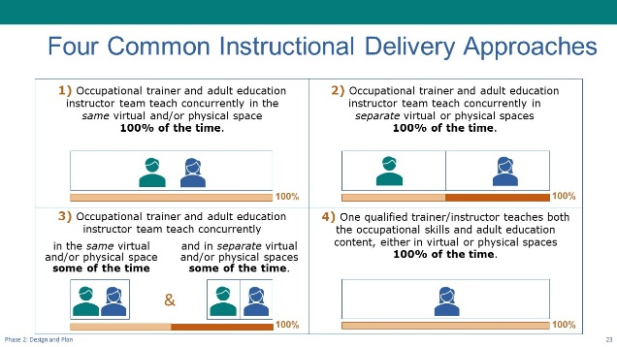
Present:
- Use the PPT slide to discuss common instructional delivery approaches using real-world examples.
- IET programs require thoughtful planning for effective delivery of the contextualized training. You’ll want to work with your partners to identify and plan out the best delivery approach for your program.
- There are four common instructional approaches for delivery:
- Occupational trainer and adult education instructor team teach 100 percent of the time in the same virtual and/or physical space. Both teachers equally plan and deliver the IET program’s instruction in the same space at the same time with the same learners.
- Occupational trainer and adult education instructor deliver instruction concurrently while in separate virtual or physical spaces 100 percent of the time. The instructor and trainer meet to discuss instructional content but, in general, plan and deliver their own instruction.
- Occupational trainer and adult education instructor team teach at least some of the time in the same virtual and/or physical space and for the remaining time they teach concurrently in separate spaces. Co-planning meetings will determine who plans and delivers the content in the team-teaching settings, and each instructor plans the content for their respective classes.
- Lastly, is the delivery approach in which one qualified instructor with the required credentials for teaching both the occupational skills and adult education content, either in virtual or physical spaces.
- TIP: Many states have policies regarding delivery approaches. Check what is already in place in your state before deciding on an approach.
- NEXT SLIDE

Poll: Delivery Approach (Optional)
Presenter: [NAME]
Duration: 2 min.
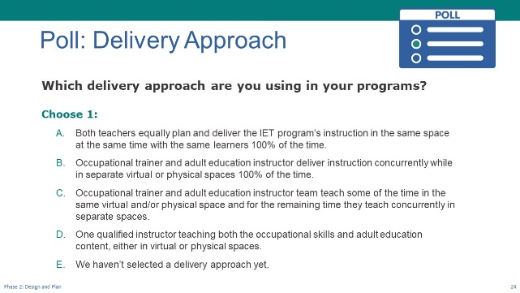
NOTE – IET Training Team:
- This is an optional slide. Delete or modify as needed. Remember to do the same in the slide deck.
Poll:
- Introduce the poll question and ask participants to respond.
- We’d like to learn more about your experience in delivery approaches. What instructional delivery approach are you using, or do you plan to use, in your IET or other adult education programs?
- In-person: Raise your hand as I read the options.
- Virtual: Please select the response that best describes your situation.
- Ask technical assistant to share results (if virtual).
- Respond to the results.
- NEXT SLIDE

Considerations When Going Virtual
Presenter: [NAME]
Duration: 2 min.
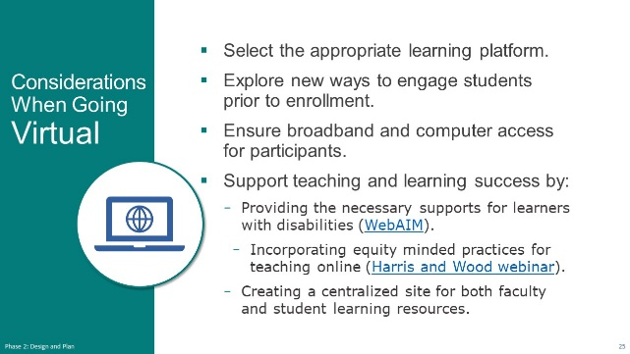
NOTE – IET Training Team:
- Tailor the slide and talking points to any state-specific resources you may have for virtual delivery.
Present:
- Use the slide to share best practices for virtual delivery of IET instruction.
- In a few minutes, we’re going to talk about the learner experience and hear about ways to access learners and support them both before and during enrollment. This is important in designing an IET program structure that’s sustainable.
- Over the years, a need for virtual outreach and support forced many programs to find innovative solutions to stay connected to learners. Many have had to turn abruptly to online options to adjust to the evolving need to offer virtual programming.
- There are some issues to consider before going virtual to determine if it’s right for you and the learners you serve. For example, you’ll need to determine which learning platform will work best for you and your learners and whether your learners will have access to the technology needed to fully participate in the IET.
- On this slide we’ve included a few resources that you may find helpful as you look for ways to support learners and enhance the online learning experience.
- It includes a website focusing on students with disabilities and a webinar focused on equity-minded practices for teaching online. These links and other resources can be found in the Toolkit.
- Lastly, it may help to create a centralized site with on online teaching and learning resources for both faculty and students.
- NEXT SLIDE

Digital Supports
Presenter: [NAME]
Duration: 1 min.
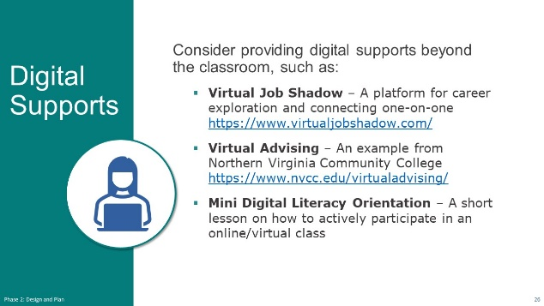
Present:
- Use the PPT slide to discuss ways to provide digital supports beyond the classroom.
- This slide provides some resources with tools and best practices for virtual, or digital, supports beyond the classroom.
- These include a virtual job shadow platform for career exploration and connecting one-on-one and an example from Northern Virginia Community College of virtual advising.
- You might also consider having a mini online session before the instructional part of the program begins to prepare learners to be active participants in virtual sessions.
- You’ll find these same resources and others in the toolkit.
- NEXT SLIDE

Group Discussion: Supporting Virtual Learning Ideas (Optional)
Presenter: [NAME]
Duration: 3 min.
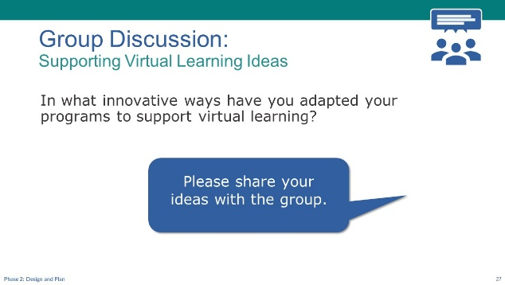
Discuss/Chat:
- Facilitate a discussion on the following question(s).
- Now we’d like to hear from you. What are some innovative ways you’ve adapted your programs to support virtual learning?
- (Virtual) Have participants share responses in the chat or unmute their microphone to speak.
- (In-Person) Ask participants to raise their hand or call out responses.
- NEXT SLIDE

2-3 Plan the Learner Experience
Start Time: [ENTER TIME]

Plan the Learner Experience – Topic Introduction
Presenter: [NAME]
Duration: 1 min.
Present:
- Introduce the topic and subtopics:
- Earlier, we identified a program-level learner goal. We know that learners are always a central consideration for adult education professionals. Therefore, it is important to understand the demographic and cultural and ethnic differences of the populations you wish to serve in your program.
- In this section you’ll engage in activity that addresses the key decision points from the perspective of the learner.
- Then we’ll talk about the four stages of the learner experience to discuss some important considerations.
- NEXT SLIDE

Breakout Group Activity #2: What does a successful IET learner experience look like?
Presenter: [NAME]
Duration: 22 min. (total)
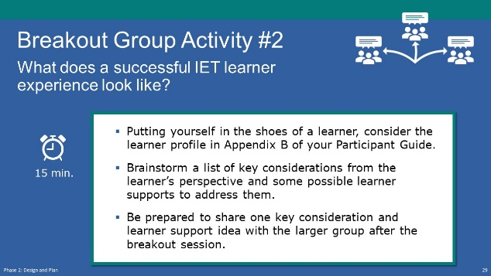
NOTE – IET Training Team:
- This is a flipped classroom approach, whereby the activity asks participants to identify important learning considerations by stage of learner experience before the trainers present the training material.
- If you are conducting the training in person, this activity can be conducted in small groups, preferably with a group facilitator.
- If you are conducting the training virtually, you will need to have the technical assistant set up the required number of breakout rooms and assign participants and group facilitators to a room (See tech note below).
Present: (1 min.)
- Explain the activity.
- For this activity you’ll put yourself in the shoes of an adult learner and, from their perspective, brainstorm any considerations or ideas you have for learner supports.
- Each room will have a facilitator to take notes and help guide the conversation.
- To make this activity more concrete we are providing you with the profile of an adult learner. Please use this profile to inform your discussions. The profile and instructions for the activity are in Appendix B of your Participant Guide if you want to follow along, but your group facilitator will also have the information.
- Think about all the touchpoints you have with students (as noted in the Toolkit) such as:
- Outreach and Recruitment
- Enrollment and Intake
- Individualized Success Plans
- Career Planning and Transition
- You’ll create a list of key considerations from the perspective of the learner and some possible learner supports that may be needed, which will help inform the design of your IET program.
- You’ll have about 15 minutes to brainstorm and then we’ll come back together to share ideas.
NOTE – Technical Assistant:
- If virtual, assign participants to one of the following breakout rooms:
- Room 1 – [FACILITATOR(S) NAME(S)
- Room 2 – [FACILITATOR(S) NAME(S)
- Room 3 – [FACILITATOR(S) NAME(S)
- Room 4 – [FACILITATOR(S) NAME(S)
- Room 5 – [FACILITATOR(S) NAME(S)
Breakout Group Activity: (15 min.)
- Facilitators:
- If in person: Use 2.B3_Design_Plan_Breakout_2_Facilitator_Guide.docx to capture your group’s key words and success statements.
- If virtual: Facilitators, instructions for facilitating this activity are on the first page of 2.B3_Design_Plan_Breakout_2_Facilitator_Guide.docx. Place yourself in the correct room (see room assignments above), open the PowerPoint file 2.B4_Design_Plan_Breakout_2_Facilitator_PPT_Virtual.pptx, and share your screen in the breakout room. Capture your group’s key considerations and potential learner supports directly on the slide.
- Facilitate a 15-minute discussion about the potential considerations for the learner profile and some potential learner supports to address them.
Allow 15 minutes for the discussion. [if virtual] Bring them back to the main room.
Activity Debrief and Transition to Next Topic: (6 min.)
- Call on a few group facilitators to share insights from the discussion. [If virtual] Have facilitators copy and paste their group’s lists into the chat window.
- Lead a discussion about any highlights or surprises from the activity.
- NEXT SLIDE

Four Stages of the Learner Experience
Presenter: [NAME]
Duration: 1 min.
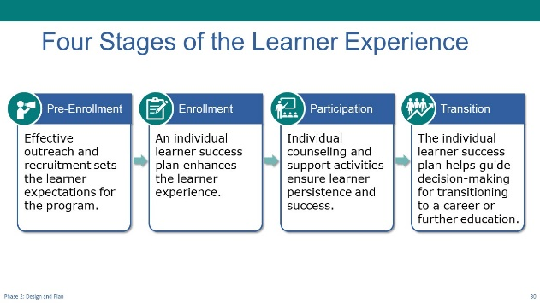
Present:
- Review the stages of the learner experience.
- There are four stages of the learner experience:
- Pre-Enrollment, where you’ll conduct outreach and recruitment activities to set the learner expectations for the program;
- Enrollment and intake, where the learner is guided in creating an individual learner success plan to enhance their experience in the program;
- Participation in the IET program, where learners receive individual counseling and support activities to ensure their persistence and success; and
- Transition out of the IET program, where the learner’s individual learner success plan helps guide their decision-making beyond the IET program and into continuing education or employment.
- We heard from the groups that a strong IET program goes beyond basic knowledge and skills building and considers the experience and support adult learners have and what they may need to succeed. We’re going to unpack each of these elements and hear more about how you’re meeting them where they are.
- The IET Program structure design will drive the experience your learner has. This begins with outreach and recruiting and continues through the transition to employment or other education opportunities. Let’s start with outreach and recruiting during pre-enrollment.
- NEXT SLIDE

1: Pre-Enrollment
Presenter: [NAME]
Duration: 2 min.
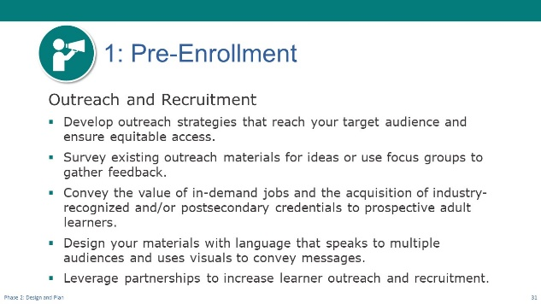
Present:
- Use the PPT slide to discuss key decision points related to pre-enrollment/outreach and recruiting.
- The first contact potential learners have with the IET program is through outreach and recruiting efforts. Work with your partners to develop strategies to brand and design messaging for the IET program based on your knowledge of the target population. You will also want to determine how to leverage partnerships to support ongoing learner outreach and recruitment and support sustainability.
- The Toolkit includes a desk aid that describes several key tasks to consider that are identified on the slide, such as:
- Developing outreach strategies that reach your target audience and ensure equitable access. Consider your target population. What are the best avenues to reach them? Through partner agencies? Social media? Print material? On-line advertising?
- Surveying existing marketing materials for ideas. Are there materials that focus on the same population or industry? Scour the web or ask partners for example materials.
- Branding your IET program’s messaging. Is there already a state brand?
- Designing your marketing materials. Focus on the end-user. You may consider hosting a focus group with learners and have them provide feedback on materials as you are drafting them.
- These are just a few to consider but I’m sure you all have more.
- NEXT SLIDE

Group Discussion: Outreach and Recruitment Strategies
Presenter: [NAME]
Duration: 2 min.
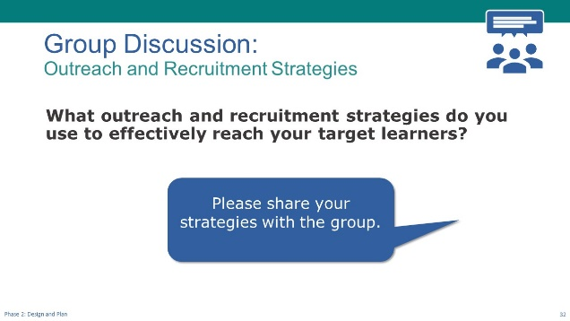
Discuss/Chat:
- If time allows, facilitate a discussion on the following question(s).
- What are some effective outreach and recruiting strategies you’ve used to reach your target learners?
- (Virtual) Have participants share responses in the chat or unmute their microphone to speak.
- (In-Person) Ask participants to raise their hand or call out responses.
- Transition to next slide.
- Let’s move to the next stage of the learner experience—enrollment and intake.
- NEXT SLIDE

2: Enrollment
Presenter: [NAME]
Duration: 2 min.
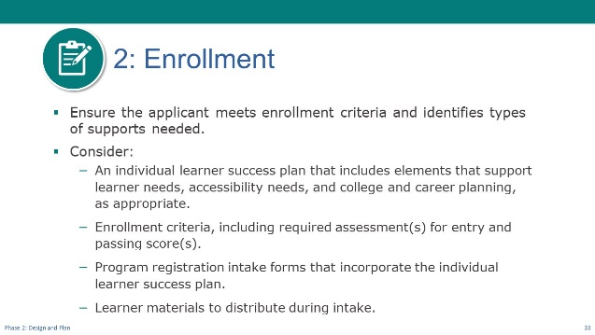
Present:
- Use the PPT slide to discuss key decision points related to the enrollment and intake process for IET.
- The learner enrollment and intake process provide an opportunity to ensure the applicant meets enrollment criteria and identifies types of supports needed to allow for smooth entry into the program and ongoing success. You’ll need to decide on:
- Enrollment criteria, including required assessment(s) for entry and passing score(s).
- Program registration intake forms that incorporate the Individual Learner Success Plan.
- Learner materials to distribute during intake.
- Consider Including the Individual Learner Success Plan into your intake process. The plan should include elements that support learner needs, accessibility needs, and college and career planning, as appropriate. The IET Toolkit provides an example intake form from Nebraska’s Adult Education State Office that can be used as a guide as you think through the design of your Individual Learner Success Plan.
- At the conclusion of the enrollment and intake process, the learner should have appropriate IET program materials and an Individual Learner Success Plan.
- NEXT SLIDE

3: Participation
Presenter: [NAME]
Duration: 1 min.
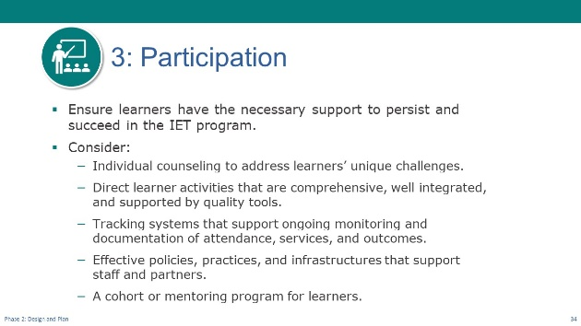
Present:
- Use the PPT slide to discuss key decision points related to participation in the IET program.
- It’s not over once the learner is in the door. Providing necessary support and building a relationship with that learner is critical throughout their participation in the program.
- The slide identifies some things to consider for providing that support.
- It’s important to decide and build these supports into the program as you design. This will help you identify the gaps in the resources/partners/systems you may have and plan strategies for addressing them.
- NEXT SLIDE

Group Discussion: Persistence and Success
Presenter: [NAME]
Duration: 2 min.
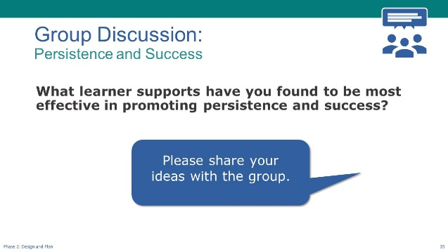
Discuss/Chat:
- If time allows, facilitate a discussion on the following question(s).
- What learner supports have you found to be most effective in promoting persistence and success?
- (Virtual) Have participants share responses in the chat or unmute their microphone to speak.
- (In-Person) Ask participants to raise their hand or call out responses.
- Speak to a few of the responses.
- NEXT SLIDE

4: Transition Support for Career Planning and Further Education or Training
Presenter: [NAME]
Duration: 1 min.
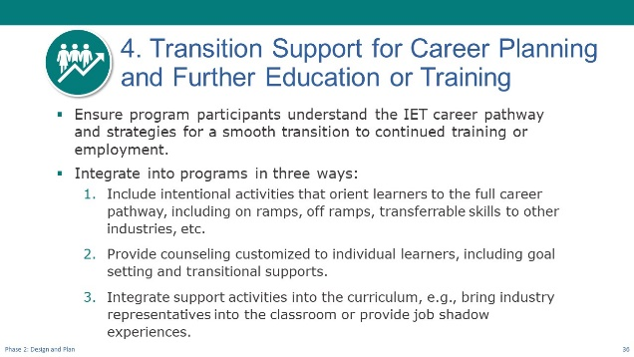
Present:
- Use the PPT slide to discuss key decision points related to career planning and transition support for IET learners.
- As we noted in session one, an IET program must be part of a career pathway and include career and college planning to ensure program participants understand the IET career pathway, their educational and vocational options, and strategies for a smooth transition to continued training or employment.
- You’ll want to consider these key ideas when planning for learner transition to employment or further education.
- Identify what you want your learners to know or be able to do as a result of your interventions, and clearly communicate these expectations.
- Intentionally include time with the learner to discuss progress toward their goals, plan, and identify potential challenges and possible supports to address them. Revisit the plan periodically.
- Include activities like individually customized college and career counseling and support in preparing for and navigating any academic transitions.
- Integrate career-focused activities into the IET program, such as bringing industry representatives into the classroom or providing job shadow experiences.
- Consider including financial literacy supports to help learners plan for upcoming expenses related to the cost of tuition and other related expenses if they are continuing on to education or training programs. Financial literacy resources may also help individuals with household budgeting and making plans and adjustments for loss of financial assistance that may occur as individuals transition to higher earnings. Financial Literacy resources are available through the Teaching Skills that Matter Toolkit at https://lincs.ed.gov/state-resources/federal-initiatives/teaching-skills-matter-adult-education.
- NEXT SLIDE

Group Discussion: Career Planning and Transition Support
Presenter: [NAME]
Duration: 2 min.
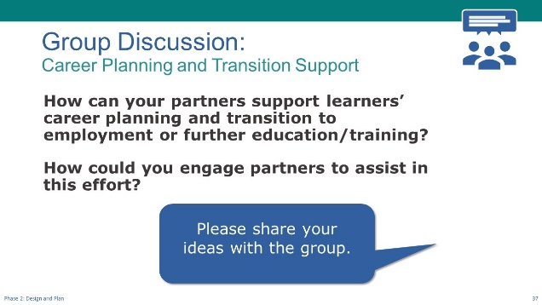
Discuss/Chat:
- If time allows, facilitate a brief discussion on the following question(s).
- How can your partners support learners’ career planning and transition to employment or further education/training?
- How could you engage partners to assist in this effort?
- (Virtual) Have participants share responses in the chat or unmute their microphone to speak.
- (In-Person) Ask participants to raise their hand or call out responses.
- Speak to a few of the responses.
- NEXT SLIDE

2-4 Create an Evaluation Plan
Start Time: [ENTER TIME]

Create an Evaluation Plan – Topic Intro
Presenter: [NAME]
Duration: 1 min.
Present:
- Introduce the topic and subtopics.
- Evaluation planning is an important part of the Design and Plan phase. It warrants more time than we have in this session, but we did want to touch on it briefly here and then we’ll go into more detail when we have the training session for the Evaluate and Improve phase.
- We’ll also discuss the Evaluation Plan Template in the IET Toolkit.
- NEXT SLIDE

Importance of Embedding Evaluation
Presenter: [NAME]
Duration: 1 min.
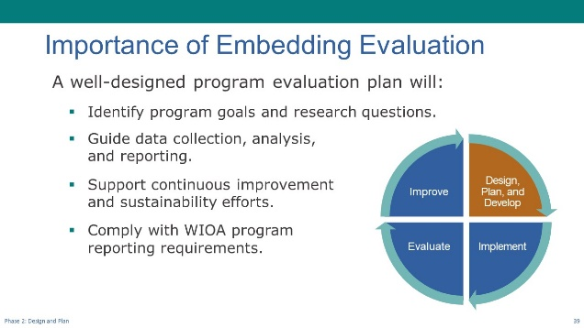
Present:
- Use the PPT slide to discuss the importance and value of creating an evaluation plan before you implement your IET program.
- This is all about planning with the end in mind. Aligning the measures and data collection to the program goals you set will guide your continuous improvement efforts while you develop and deliver the IET program. It will also help you think about how you want to engage your team, partners and funders in understanding what works and what needs to be changed moving forward.
- The graphic on the slide depicts the cycle of continuous improvement, moving from designing, planning, and developing the program to implementing it, and then evaluating and continuously improving the program based on the evaluation findings.
- These activities overlap in your work. The main takeaway here is to expect and plan for adjusting and improving your program as you go. We’ll talk more about continuous improvement and the continuous improvement cycle in the Evaluate and Improve phase.
- NEXT SLIDE

Evaluation Plan Template
Presenter: [NAME]
Duration: 1 min.
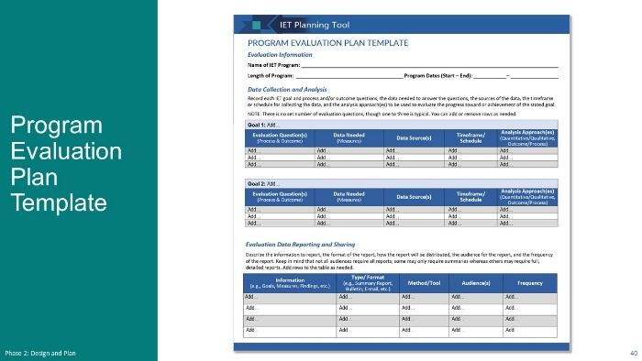
Present:
- Explain that the Evaluation Plan Template in the IET Planning Tool can help their team develop their evaluation plan.
- The IET Toolkit includes a template your team can use or modify to create an evaluation plan that meets your program’s needs.
- Starting with your high-level IET goals we discussed earlier, you’ll think about the questions you’ll need to answer to measure the program’s progress toward or achievement of the goals.
- You’ll also examine the quality of the program’s processes and the effectiveness of the IET curricula and delivery of instruction to determine the impact they had on the outcomes.
- Notice there is a column for the data you’ll need to collect and analyze to answer your process and outcome questions, and the sources for those data.
- In the last column, you’ll identify the type of data analysis or evaluation you’ll conduct. More about data and data analysis in Phase 4.
- Think of your evaluation plan as a living document—you can update it as you go through the program development process.
- Looking at the column headers in this plan helps us understand why it’s important to start this planning while you are designing the session. Matching goals to measures to data needed to address those measures is part of the Design Phase.
- Again, we’ll talk more about this in Phase 4, but starting the planning in the Design and Plan phase will facilitate your success.
- NEXT SLIDE

2-5 Wrap-Up
Estimated Start Time: [ENTER TIME]

Wrap-Up - Topic Intro
Presenter: [NAME]
Duration: 1 min.
Present:
- Explain that we will wrap up the session by:
- Reviewing some key takeaways from this session.
- Reflecting on what you learned, what stood out to you, and what questions you may have.
- Conducting a quick poll.
- Going over next steps.
- NEXT SLIDE

5 Key Takeaways
Presenter: [NAME]
Duration: 2 min.
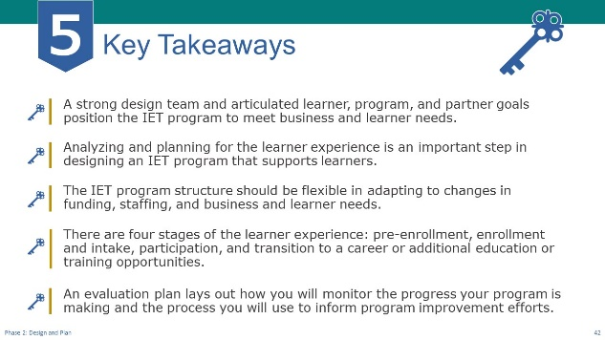
NOTE – Technical Assistant:
- This slide has 4 builds/clicks to display the key takeaways one a time as the facilitator discusses each (see below).
Present:
- Review key takeaways.
- A strong design team positions the IET program to meet business and learner needs.
- Analyzing and planning for the learner experience is a crucial aspect of designing an IET program that supports the unique needs of a diverse set of learners.
- The IET program structure should be flexible in adapting to changes in funding, staffing, and business and learner needs.
- There are four stages of the learner experience: pre-enrollment, enrollment and intake, participation, and transition to a career or additional education or training opportunities.
- An evaluation plan lays out how you will monitor the progress your program is making and the process you will use to inform program improvement efforts.
- NEXT SLIDE

Group Discussion: Reflection (Optional)
Presenter: [NAME]
Duration: 10 min.
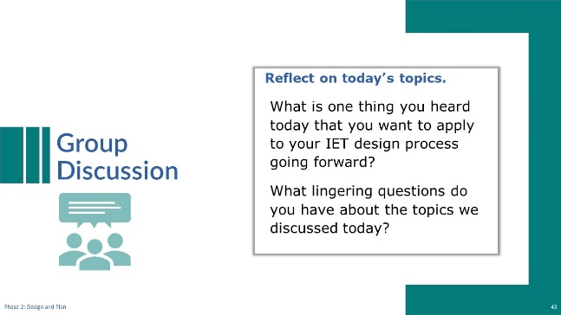
NOTE – IET Training Team:
- This is an optional discussion that can be conducted with the whole group of participants, or you may choose to conduct it in breakout groups and then ask groups to share one or two things they discussed.
Discuss:
- Lead a group discussion reflecting on what was covered in this phase.
Possible questions:
- What is one thing you heard today that you want to apply to your IET design process going forward?
- What lingering questions do you have about the topics we discussed today?
- As time allows, ask if there are any questions about what was covered in this session.
- NEXT SLIDE

Poll: Confidence Level (Optional)
Presenter: [NAME]
Duration: 2 min.
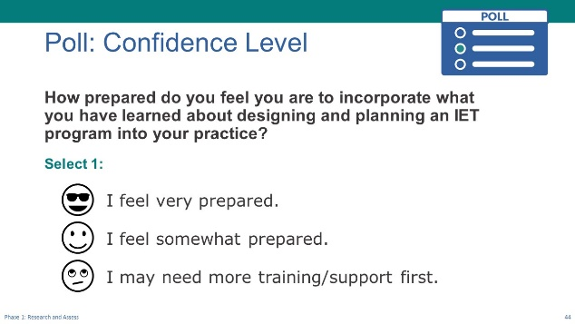
NOTE – IET Training Team:
- This is an optional poll. You can choose to delete or modify it as needed. Remember to do the same in the slide deck.
Poll:
- Introduce the poll question and ask participants to respond.
- How prepared do you feel you are to incorporate what you have learned about designing and planning an IET program into your practice?
- I feel very prepared.
- I feel somewhat prepared.
- I may need more training/support first.
- If you are delivering the training in-person, read the options and have participants raise their hands (“Raise your hand if you feel very prepared.” “Who feels somewhat prepared?” “Raise your hand if you feel you may need more training or support first?”).
- If virtual, ask technical assistant to launch poll and give participants a little time to respond, then share the results.
- NEXT SLIDE

Next Steps
Presenter: [NAME]
Duration: 2 min.
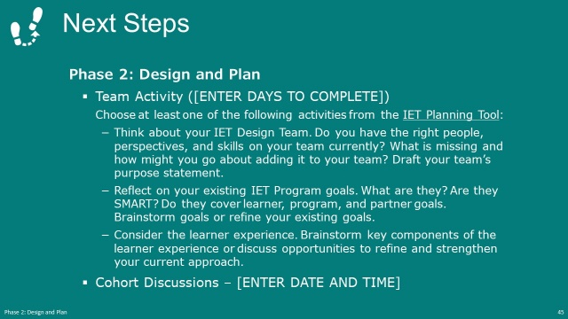
NOTE – IET Training Team:
- Modify this slide and the next to fit your structure and schedule. For example, add dates and times where indicated. If you are not doing cohorts, remove the last bullet on this slide.
Present:
- Use the PPT slide to talk through the team activity and the next cohort meeting (if applicable).
- NEXT SLIDE

Next Steps (cont.)
Presenter: [NAME]
Duration: 1 min.
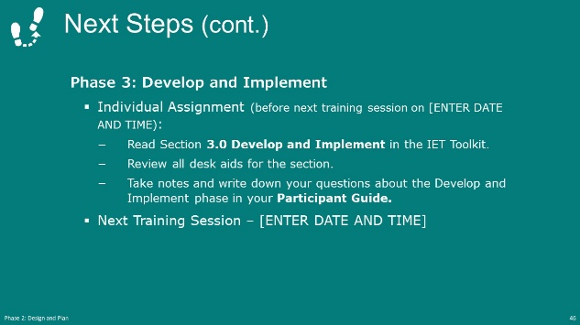
NOTE – IET Training Team:
- Modify this slide and the next to fit your structure and schedule. Add dates and times where indicated.
Present:
- Explain the individual assignment to do before the next session and restate the date and time of the next session (if applicable).
- Thank everyone for their participation and end session.

After the Session

Follow-Up Recommendations
- Send an email to check in with participants before the next training session.
- Remind them of the homework assignment, the date and time of the cohort meeting (if applicable), and the date and time of the next Design Camp training session.
- Suggest that participants review the Develop and Implement section of the IET Toolkit, including any desk aids and tools.
- Remind participants to write down any questions they have in their Participant Guide as they review the Develop and Implement section and bring them to the next training session.

