IET Design Camp Phase 2: Design and Plan
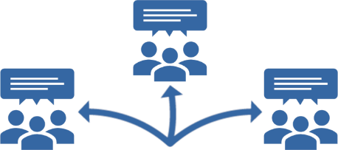

Breakout Group Activity #1

What does a successful IET program look like?
15 minutes

Facilitator Instructions:
- Work with the breakout group members to come to a consensus on two or three sentences that describe a successful IET program.
- Start by having participants brainstorm key words to get ideas flowing.
- Then have them craft the success sentences using some of those key words.
- Capture key words and document the success statements.
  - [If in-person] Use the next page of this handout to capture the information.
  - [If virtual] Open the 2.B2_Design_Plan_Breakout_1_Facilitator_PPT_Virtual.pptx and share your screen. Capture the information directly on the slide as the group works through the activity.
- You will share these sentences with the larger group during the activity debrief.
[If virtual] Copy and paste the sentences into the chat window once you are back in the main room.

A strong success statement might include the following:

- Clearly defined program goals
- Reliable funding sources
- Clear communication
- Committed partners
- Engaged stakeholders
- High learner completion rate

Key Words

- Blank space to write key word
- Blank space to write key word
- Blank space to write key word
- Blank space to write key word
- Blank space to write key word
- Blank space to write key word
- Blank space to write key word
- Blank space to write key word
- Blank space to write key word
- Blank space to write key word
- Blank space to write key word
- Blank space to write key word
- Blank space to write key word
- Blank space to write key word
- Blank space to write key word
- Blank space to write key word

Success Statement(s): Blank area to write

