IET Design Camp

Facilitator Guide for

CLOSING SESSION

Facilitator Guide for IET Design Camp
Closing Session

Introduction
Welcome to the Facilitator Guide for the virtual or in-person delivery of the IET Design Camp Closing session. This guide outlines everything you need to know to facilitate the training, including logistics, training materials, learning objectives, timing, and talking points for each slide. Training teams should a) review this guide and the corresponding training materials (see below) and b) make modifications based on who is delivering the training, when s/he will deliver the training, and how s/he will deliver the training.

Logistics
Date: [ENTER DATE]
Time: [ENTER TIME AND TIME ZONE]
Estimated Run Time: 1.5 hours [EDIT ESTIMATED TIME AFTER CUSTOMIZING SLIDES]
Technical Assistant: [ENTER TECHNICAL ASSISTANT NAME]
Moderator(s): [ENTER MODERATOR NAME(S)]
Trainers/Facilitators: [ENTER TRAINER/FACILITATOR NAME(S)]

Overview
This closing session will provide participants with a summary of resources available and allow for discussion of the Evaluate and Improve phase and next steps for implementing IET programs.

Training Materials
- PowerPoint Deck: 5.A2_Closing_PPT.pptx
- Participant Guide: Participant_Guide.docx
- Breakout Group Activity File(s):
- [Virtual]: 5.B1_Closing_Breakout_2_Facilitator_Guide_Virtual_PPT.docx

Objectives
After completing this session, participants will be able to:
- Describe an overall approach for IET program continuous improvement.
- Identify resources available to them through the IET Toolkit and [INSERT other state resources].

6-0 Overview/Introduction
Start Time: [ENTER TIME]

- IET Design Camp Closing Session
Presenter: [NAME]
Duration: 1 min.
Present:
- Welcome participants to the session and provide a brief overview of this session.
- Welcome to the closing session! Thank you all for being here as we wrap up the training series.
- Throughout the Design Camp, we’ve introduced a lot of new concepts, promising practices, and useful resources to help you develop effective IET programs that meet the needs of learners, employers, and the community.
- Today we’re here to celebrate the progress you’ve made in the Design Camp and to share additional ideas and resources with one another.
NEXT SLIDE
- Virtual Meeting Recording Notice (OPTIONAL)
Presenter: [NAME]
Duration: 0.5 min.
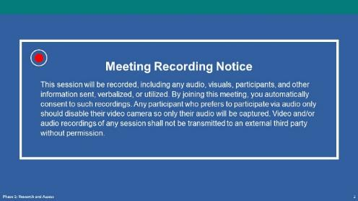
NOTE – IET Design Team:
- This is an optional slide. If you are delivering the training in person or do not need a recording notice, delete this slide from this Guide and the PowerPoint deck.
Present:
- Remind people that we will record today’s session.
NEXT SLIDE
- Virtual Classroom Reminders (Optional)
Presenter: [NAME]
Time: 0.5 min.
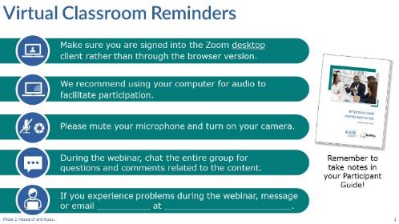
NOTE – IET Training Team:
- This is an optional slide. If you are delivering the training in person, delete this slide from the PowerPoint slide deck and from this Facilitator Guide. If you are delivering the training on another platform, edit this slide accordingly.
Present:
- Review virtual classroom reminders.
- Please take a moment to read through these reminders, and make sure you’re ready to participate in the session.
- You may want to open your Participant Guide to take notes or refer to any questions you had during the Evaluate and Improve session.
- Agenda
Presenter: [NAME]
Duration: 1 min.
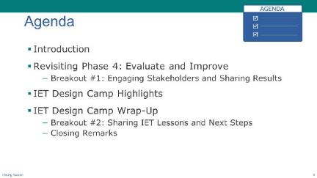
Present:
- Review the agenda.
- Today, our goal is to spend most of the time together in breakout groups, sharing some ideas related to the last training session on Evaluate and Improve. We’ll also share ideas and discuss next steps for your IET Development processes.
- We’ll start with a brief review of Phase 4: Evaluate and Improve and then we’ll look back on the entire training series and highlight some key concepts and remind you about the resources available to you as you develop or enhance your IET programs.
- Finally, we’ll wrap up the Design Camp by summarizing what we’ve learned and what’s next for [INSERT STATE] regarding IET programs.
NEXT SLIDE
- Today’s Trainers
Presenter: [NAME]
Duration: .5 min.
Present:
- Introduce the trainers or have them introduce themselves.
NEXT SLIDE
- IET Design Camp – We are Here
Presenter: [NAME]
Duration: .5 min.
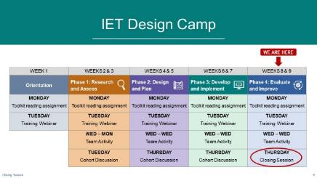
NOTE – IET Training Team:
- You should have already developed a table that reflects the structure and organization of your Design Camp for the Orientation session. You may want to copy and paste your table onto this slide and move the “WE ARE HERE” and arrow to the Phase 4 column. You may want to circle the activity you are on (Closing Session).
- If you are not doing team activities and/or cohorts, modify or remove the second sub-bullet below.
Present:
- Orient participants to where you are in the Design Camp—Closing session. Tailor your talking points to reflect the design and schedule of your training. For example:
- Today we’re in the Closing session to wrap up the Design camp. This session will be a bit more informal as we’ll be reviewing some of the key concepts and tools and we’ll also share with each other in a couple of breakout group activities.
- Now let’s get started with the session.
NEXT SLIDE

6-1 Revisiting Evaluation and Continuous Improvement
Start Time: [ENTER TIME]
- Revisiting Evaluation and Continuous Improvement – Topic Introduction
Presenter: [NAME]
Duration: 1 min.
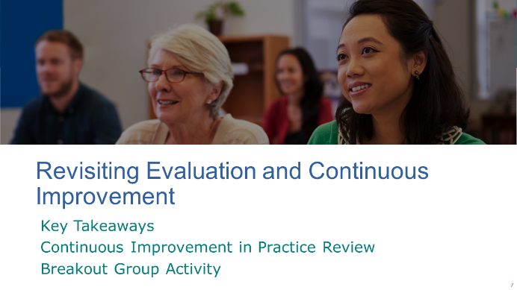
Present:
- Introduce the topic.
- We’re going to take a few minutes to revisit some of the key concepts and resources we talked about in Phase 4: Evaluate and Improve.
- We looked at various components of an evaluation plan and shared some ideas around developing process and outcome questions, collecting, and analyzing data, and sharing results.
- We’ll review what continuous improvement cycle looks like in practice and then you’ll have an opportunity to share ideas for engaging stakeholders and sharing evaluation results.
NEXT SLIDE
- Review of Phase 4: Evaluate and Improve
Presenter: [NAME]
Duration: 3 min.
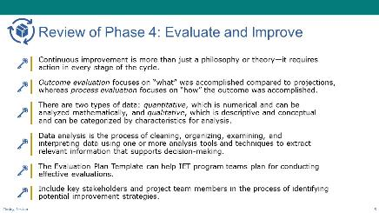
Present:
- Review key takeaways from Phase 4.
- We covered a lot of ground in the last session. Let’s review a few key takeaways.
We started by talking about continuous improvement and the continuous improvement cycle. Continuous improvement is more than just a philosophy or theory—it requires action in every stage of the cycle. The continuous improvement cycle represents the iterative nature of the continuous improvement process.
We discussed two types of evaluation: outcome and process evaluation. Remember that outcome evaluation focuses on “what” was accomplished compared to what you expected to accomplish. In other words, how effective the program is in producing change, whereas process evaluation focuses on “how” the outcome was accomplished—what worked well, what didn’t work well, and why? Remember that it’s in the process evaluations that you’ll see opportunities to improve any outcomes that fell below expectations.
As we moved into the topic of identifying data and data sources, we talked about two types of data: quantitative, which is numerical and can be analyzed mathematically, and qualitative, which is descriptive and conceptual and can be categorized by characteristics for analysis. Once you have your outcome and process questions, you’ll want to identify the data you need to answer the questions and where you will obtain those data.
Your evaluator or evaluation team will analyze the data collected as you implement your program. Data analysis is the process of cleaning, organizing, examining, and interpreting data using one or more analysis tools and techniques to extract relevant information that supports decision-making.
It’s important to include key stakeholders and project team members in the process of identifying potential improvement strategies. Remember, people support what they help create. Your evaluation plan should describe how your team will make decisions about improvement.
And finally, the Program Evaluation Plan Template provided in the IET Planning Tool of the IET Toolkit helps IET program teams plan steps for conducting effective evaluations, whether in-house or third-party evaluations.
NEXT SLIDE
- Continuous Improvement in Practice – Review
Presenter: [NAME]
Duration: 2 min.
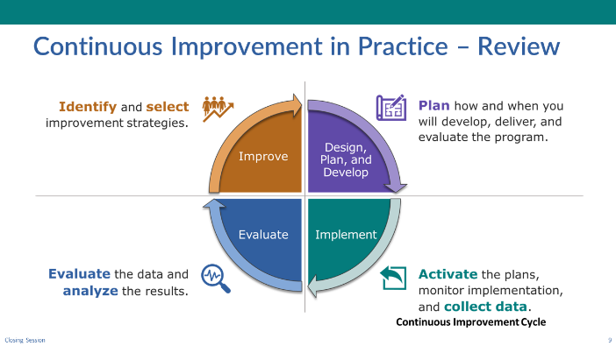
NOTE – Technical Assistant:
- This slide has three builds (clicks) to display descriptions of the stages one at a time as the facilitator reviews each.
- The continuous improvement cycle graphic starts out in the same position as the previous slide but slides to the center upon entry of this slide.
Present:
- Reinforce how continuous improvement works in practice by reviewing what happens in each stage of the continuous improvement cycle.
- As a reminder, it’s important to plan how and when you’ll develop, deliver, and evaluate the program as you’re designing and developing it. Having a well-documented evaluation plan will help you across these steps.
[CLICK TO DISPLAY NEXT STAGE]
- As you move into implementation and deliver the training using the curricular materials you developed, you want to monitor the implementation of the planned strategies and collect data according to your evaluation plan. Remember that it’s important to observe whether you are delivering the program as planned, or with fidelity, so that you can accurately measure the impact of your planned intervention strategies and inform continuous improvement decisions.
[CLICK TO DISPLAY NEXT STAGE]
- During training delivery and once it’s completed, you will evaluate the data collected and analyze the results against the established program goals. You’ll also share the results with stakeholders.
- Remember to pay attention to processes so that you can identify opportunities for improvement.
[CLICK TO DISPLAY NEXT STAGE]
- Finally, you’ll use the results of your analysis to identify and select improvement strategies and explore short- and long-term investments of resources to make program improvements.
- But remember this is a cycle, so that’s not the end. You’ll need to design and develop your selected improvement strategies, and then implement and monitor, evaluate and analyze, and the cycle continues.
NEXT SLIDE
- Breakout Group Activity #1: Engaging Stakeholders and Sharing Results
Presenter: [NAME]
Duration: 20 min. (total)
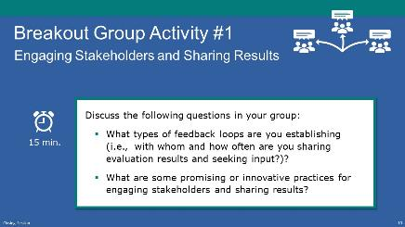
NOTE – IET Training Team:
- If you are conducting the training in person, this activity can be conducted in small groups, preferably with a group facilitator.
- If you are conducting the training virtually, the technical assistant will need to set up the required number of breakout rooms and assign participants and group facilitators to a room (See tech note below).
Present: (1 min.)
- Explain the activity.
- In your breakout groups, we’d like you to discuss ideas around how you’re taking results from your evaluation and continuous improvement efforts and sharing them with your program team, instructors, and stakeholders.
- Key questions to explore during your discussion include:
- What types of feedback loops are you establishing (i.e., with whom and how often are you sharing evaluation results and seeking input?)?
- What are some promising or innovative practices for engaging stakeholders and sharing results?
- You’ll have about 15 minutes.
NOTE – Technical Assistant:
- If virtual, assign participants to one of the following breakout rooms:
- Room 1- [FACILITATOR(S) NAME(S)
- Room 2- [FACILITATOR(S) NAME(S)
- Room 3- [FACILITATOR(S) NAME(S)
- Room 4- [FACILITATOR(S) NAME(S)
- Room 5- [FACILITATOR(S) NAME(S)
Breakout Group Activity: (15 min.)
FACILITATORS:
- [If virtual] Place yourself in the correct room (see room assignments above).
- Facilitate a 15-minute discussion about the process they used to get feedback from stakeholders and disseminate information out to them.
- Open with the idea that there is a wide variety of practice in the field about how to incorporate efforts to make program improvements into everyday work.
- We know there’s a wide variety of practice in the field about how to incorporate efforts to make program improvements into everyday work. There is the required program performance reporting we’re all familiar with, but I want to encourage you to think more broadly about how to improve our programs. Let’s home in on the idea of feedback loops into our program design or delivery.
- If needed, prompt discussion with the following questions:
- Does anyone have recurring practices to check in with your teams about day-to-day service improvement—potentially outside/beyond IET?
- How are you gathering input from instructors?
- How are you gathering input from students?
- How are you gathering input from partners?
- As you set up your design team, have you asked yourselves if someone has the role to think about evaluation/continuous improvement?
- When considering the learner experience, do you incorporate feedback from students? If so, how?
- What about supportive services or handoffs—are you reviewing how those processes work for your staff and students?
- Who handles sharing results with stakeholders? Which partners do you engage—potentially the workforce board, employers, education partners? What ways do you use to communicate?
Allow 15 minutes for the discussion, then bring them back to the main room (if virtual).

Activity Debrief (5 min.)
- As time allows, call on a few group facilitators to briefly share highlights and insights from their group’s discussion.
- [If virtual] Have facilitators copy and paste their highlights into the chat window once back on the main room.
NEXT SLIDE

6-2 IET Design Camp Highlights
Estimated Start Time: [ENTER TIME]

- Design Camp Highlights – Topic Introduction
Presenter: [NAME]
Duration: 1 min.
Present:
- Introduce the topic and subtopics.
- Let’s take a look back at some of the highlights of the Design Camp. We’ll review some key concepts and tools and reflect on those that will be most helpful to you in your practice.
NEXT SLIDE
- 3 Guiding Principles of IET Program Design
Presenter: [NAME]
Duration: 2 min.
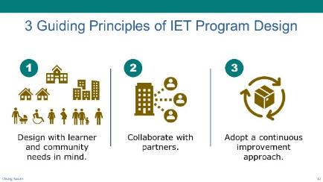
Present:
- Review the Guiding Principles of IET Program Design.
- Early in the Design Camp we shared three guiding principles for quality IET program design. Whether you’re just starting out or have been implementing an IET for a while, we think they’re important reminders.
- The first is to design with learner and community needs in mind. Putting these needs at the center of program selection and design work help ensure that programs are relevant, effective, and successful in helping learners advance in their careers and education. Having a designer's mindset of creativity, adaptability, and innovation help here too.
- The second is to collaborate with partners. We’ve talked a lot about this throughout the sessions together--the work of integrating education and training and supporting learner’s successful transition into work or further education can’t be done by adult educators alone. We’ve heard in our breakout sessions about the challenges faced here—especially in terms of finding the right partners and the time needed to build the relationships. But it’s all worth it to make sure you have employer partners who engage in the training design and hiring your IET completers, training providers who co-plan and co-teach in authentic ways, and active support partners that help address the variety of needs your students and instructors face. It was also terrific to hear you all talk about your successes in partnership building as we went through the training.
- The third is to adopt an approach of continuous improvement. Business, community, and learner needs are continually shifting, resulting in a need to be flexible and adapt as you learn about new evidence-based good practices. It will be helpful for you to use your available program data to test new approaches, capture lessons learned, look for those things that aren’t working or could be better done by another entity, and then build on the successful elements of your IET program to adapt to changing needs.
NEXT SLIDE
- Integrating IET Components
Presenter: [NAME]
Duration: 2 min.
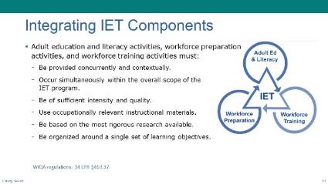
Present:
- Use the PPT slide to discuss components.
- We also want to take a minute to talk about the foundation for an IET program.
- By now the WIOA requirements should be pretty much ingrained into your vocabulary and thinking about IET programs, but let’s refresh.
- The elements of an IET program must be provided concurrently and contextually meaning that the adult education and literacy standards, workforce preparation activities, and workforce training skills occur simultaneously within the overall scope of the IET program and use occupationally relevant instructional materials to contextualize the adult education and literacy standards being taught.
- Additionally, as you design your IET program, keep in mind that each component of an IET program must be of sufficient intensity and quality.
- One way to ensure that your IET program is a quality one, is to base it on the most rigorous research available, particularly with respect to improving reading, writing, mathematics, and English proficiency of eligible individuals.
- The organization of these components around a single set of learning objectives is key.
NEXT SLIDE
- Four Iterative Phases of IET Program Design
Presenter: [NAME]
Duration: 2 min.
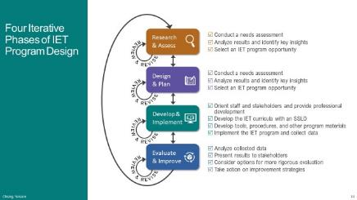
Present:
- Review the phases of IET Program Design and their key tasks.
- Over the course of our sessions, we touched on a lot of content. But as you know, there is certainly more content that the Toolkit addresses that we weren’t able to cover. We hope you’ll dive into it as you make progress implementing your IET programs.
- Thinking back to the Research and Assess Phase, we talked about the importance of conducting a needs assessment in five key areas:
State and Local IET Policy and Career Pathways Options
Regional Workforce Development Needs
Community Resources to Support your Program
Emerging and Promising Practices in IET Programs
Learner and Business Needs
- In this phase you analyzed the results of the needs assessment and identify key insights before selecting an IET program opportunity based on your analysis.
- During the Design and Plan Phase, we focused on the importance of establishing a Design Team and setting SMART program, learner, and partner goals. We also touched on elements of program structure, such as determining the instructional delivery approach for your program, understanding your funding mechanisms, designing a communication plan, and establishing written policies and partner agreements. In addition, we addressed the learner experience and considering the outreach, recruitment, enrollment, intake, and support for the transition to additional learning or employment.
- When we discussed the third phase, Develop and Implement, we spent time digging a bit deeper into the critical effort it takes to build a single set of learning objectives, or SSLO. We walked through the steps of one approach for creating standards-based curricula with a SSLO. Using program-level learner goals we identified high-level (unit or module), integrated performance objectives for the SSLO. After confirming the SSLO is aligned with your program-level goals and outcomes and making adjustments, you’ll be ready to build out your contextualized units of instruction with lesson plans, activities, and assessments.
- Finally, in the fourth phase, Evaluate and Improve, we emphasized how continuous improvement efforts should be embedded across the IET design and development work, discussing the need to identify program measures that align to your program goals, and thinking through the data collection and analysis you’ll conduct to understand if your program is achieving its intended results. We talked a bit about sharing results of your program evaluation efforts with different audiences as well. You all shared some great ideas on this in our previous breakout session.
NEXT SLIDE
- Design Camp Materials
Presenter: [NAME]
Duration: .5 min.
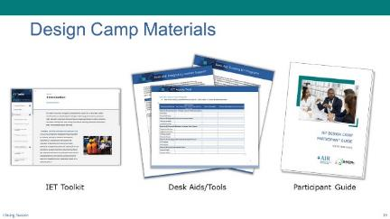
Present:
- Use the PPT slide to review resources—toolkit, desk aids and participant guide
- We wanted to take just a quick minute to remind everyone about the resources we have used during the design camp and that we hope you will continue to use as you design your IET programs.
NEXT SLIDE
- IET Assess Tool: Identifying a High-Impact IET Opportunity
Presenter: [NAME]
Duration: 1 min.
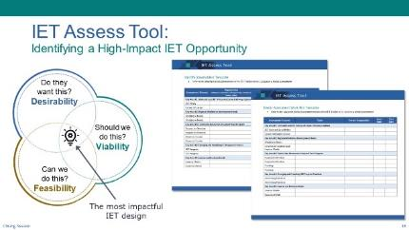
Present:
- Discuss the IET Assess tool.
- As we learned in Phase 1: Research and Assess, the IET Toolkit has an Assess Tool that you can use to select a viable, desirable, and feasible program that will meet community needs and underscore your value in the broader workforce development system.
- This tool walks you thought a set of questions, such as:
What unmet needs does our community have that IET can help address?
What learner populations might we serve?
What learner needs might we address through the IET program design?
What industries and occupations might we target?
What partners do we need for this work?
NEXT SLIDE
- IET Planning Tool: Supporting Design, Development, Implementation, and Evaluation
Presenter: [NAME]
Duration: 1 min.
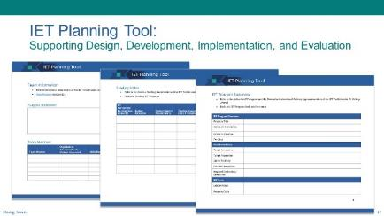
Present:
- Use the PPT slide to discuss the IET Planning tool as a tool that supports the design, development, implementation, and evaluation of IET programs.
- Another one of the key desk aids in the IET Toolkit is the IET Planning Tool which we covered in Phase 2: Design and Plan. This tool can help your design and development efforts and keep track of key information about your IET program.
- This tool provides an area for you to document your team purpose statement, key program information, funding sources, communication plans, and the evaluation plan.
NEXT SLIDE
- Using the Desk Aids to Guide Design and Development of the Four Stages of the Learner Experience
Presenter: [NAME]
Duration: 1 min.
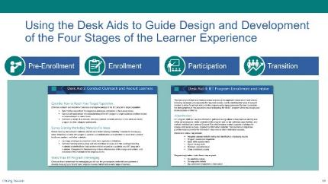
Present:
- Continue discussing toolkit resources.
- In the Design and Plan phase we talked about the stages of the learner experience. Remember that there are two desk aids that can help you think about outreach and recruitment, as well as program enrollment and intake of learners.
- Desk Aid 4 includes the concept of the Individual Learner Success Plan, which you may want to use in your intake process to support learner needs, accessibility needs, and college and career planning, as appropriate.
NEXT SLIDE
- SSLO Rubric
Presenter: [NAME]
Duration: 1 min.
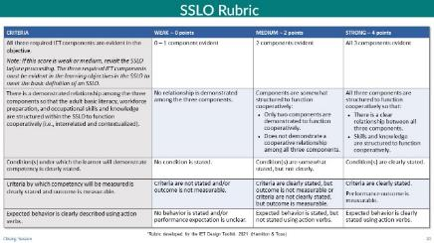
Present:
- Continue discussing toolkit resources.
- During our discussion of Phase 3: Develop and Implement, we focused on processes and tools to ensure that the IET curricula is designed and developed around a single set of learning objectives. The SSLO identifies and integrates the adult education content, workforce preparation activities, and workforce training competencies.
- One tool we shared is a rubric for building strong, integrated learning objectives that are performance-based. The rubric looks at key criteria:
Are all three required components represented and evident?
Are the components integrated?
Is the condition under which competency will be measured clearly stated?
Are the criteria by which competency will be measured clearly stated?
Is the behavior or action the learner will perform to demonstrate competency clearly stated using action verbs? In other words, are the objectives clearly stated so that expectations and goals are easily identified and understood by the learner?
NEXT SLIDE
- Group Discussion: How will you use the tools and apply the skills?
Presenter: [NAME]
Duration: 4 min.
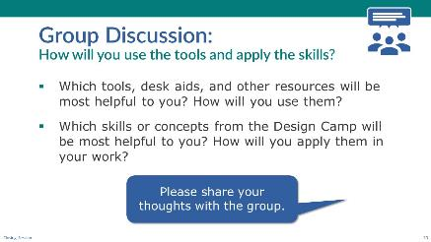
Discuss/Chat:
- Facilitate a discussion with the whole group on the following question(s).
- Now that we have reflected on the four phases of IET design and development and reviewed some of the tools provided in the IET Toolkit, let’s talk about your plans to use this training and these tools in your work.
Which tools do you think you’ll use and how will you use them?
Which skills or concepts from the Design Camp do you think will be most helpful to you? How do you plan to apply them to your practice?
- [If In-Person] Ask participants to raise their hand or call out responses.
- [If Virtual] Have participants share responses in the chat or unmute their microphone to speak.
NEXT SLIDE

6-3 IET Design Camp Wrap-Up
Estimated Start Time: [ENTER TIME]

- IET Design Camp Wrap-Up – Topic Introduction
Presenter: [NAME]
Duration: 1 min.
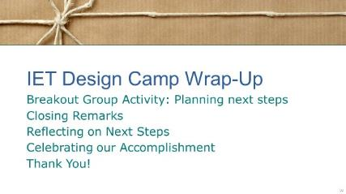
Present:
- Introduce the topic and subtopics:
- Now, we’d like to take some time to celebrate the progress you’ve made, reflect on what you’ve learned, and look ahead at the next steps you plan to take as you design and implement your IET programs.
- We’ll start with a breakout group activity—our last of the Design Camp.
NEXT SLIDE
- Breakout Group Activity #2: Planning next steps
Presenter: [NAME]
Duration: 24 min. (total)
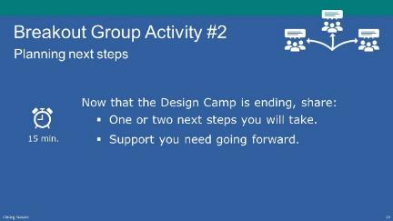
NOTE – IET Training Team:
- If you are conducting the training in person, this activity can be conducted in small groups with or without a group facilitator (preferably with).
- If you are conducting the training virtually, you will need to have the technical assistant set up the required number of breakout rooms and assign participants and group facilitators to a room (See tech note below).
- Tailor the discussion topics according to your plans for future support of IET.
Present: (1 min.)
- Explain the activity.
- Now that the Design Camp is ending, think about what’s next for you and your team.
- In this last breakout group activity, we want you to take some time to think about and share your next steps in your IET design and development. This will vary, depending on where you are in the process.
- Also, discuss the support you’ll need going forward.
- You’ll have 15 minutes for this activity.
NOTE – Technical Assistant:
- [If virtual] assign participants to one of the following breakout rooms:
- Room 1- [FACILITATOR(S) NAME(S)
- Room 2- [FACILITATOR(S) NAME(S)
- Room 3- [FACILITATOR(S) NAME(S)
- Room 4- [FACILITATOR(S) NAME(S)
- Room 5- [FACILITATOR(S) NAME(S)
Facilitated Breakout Group Activity (15 min):
FACILITATORS
- [If virtual] Place yourself in the correct room (see room assignments above).
- Open 5.B1_Closing_Breakout_2_Facilitator_Guide_Virtual_PPT.pptx. You may want to share your screen.
- Facilitate a 15-minute discussion about 1 or 2 next steps participants will take to implement an IET program and what support they need going forward. Capture notes directly onto the slides.
- Plan to share out high level areas of discussion with the full group.
- If time permits, ask: “How might we further support each other after the Design Camp ends?”
Timing:
- Allow 15 minutes for the discussion. [If virtual] Bring them back to the main room.
Activity Debrief (8 min.)
- As time allows, call on a few groups or group facilitators to briefly share some next steps and needed support from their group.
- [If virtual] Have facilitators copy and paste some next steps and needed support from their group’s discussion into the chat window once back on the main room. Select a few to discuss (ask questions, provide feedback, etc.).
NEXT SLIDE
- Closing Remarks: Continued Investment in IET (optional)
Presenter: [NAME]
Duration: 3 min.
NOTE – IET Training Team:
- This is an optional slide that you can use to provide closing remarks, promote IET, and reiterate its value in meeting community needs.
- Tailor the talking points according to your plans for future support of IET.
Present:
- Present a reminder for why IETs remain important in your state. For example:
- Thank you all for the time and effort you put into your work every day. The work you do is essential to helping adults thrive in their communities. I know you’re continuing to face challenges in doing this work- everything from recruiting and enrolling students to identifying supports that can help them persist.
- As the IET Design Camp comes to a close, let’s return to our vision for emphasizing the use IETs in [INSERT STATE].
- The services you provide through IETs, career pathways, and other adult education programming help prepare adult learners for work. IETs are needed now more than ever to help adult learners effectively advance their career and education goals while meeting the needs of employers.
NEXT SLIDE
- What are our next steps? (Optional)
Presenter: [NAME]
Duration: 2 min.
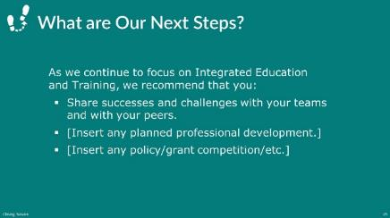
NOTE – IET Training Team:
- This is an optional slide that you can use to share next steps for IET in your state or to recommend actions that participants can take to continue their professional development in IET.
- Tailor the talking points according to your needs.
Present:
- Share next steps for IET in your state.
- As we continue to focus on IET, we hope that you’ll:
Share successes and challenges with your teams and peers.
Take additional professional development on the topic of IETs.
Watch for upcoming funding announcements.
[INSERT additional talking points as needed.]
NEXT SLIDE
- Poll: Overall Satisfaction (Optional)
Presenter: [NAME]
Duration: 2 min.
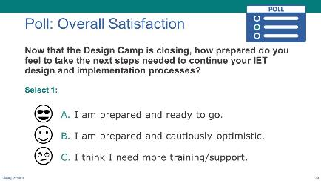
NOTE – IET Training Team:
- This is an optional poll. You can choose to delete or modify it as needed. Remember to do the same in the slide deck.
Poll:
- Introduce the poll question and ask participants to respond.
- Now that the Design Camp is closing, how prepared do you feel to take the next steps needed to continue your IET design and implementation processes?
- Please indicate the extent to which you are prepared:
1 = I am prepared and ready to go.
2 = I am prepared and cautiously optimistic.
3 = I think I need more training/support.
- If you are delivering the training in-person, read the options and have participants raise their hands.
- If virtual, ask technical assistant to launch poll and give participants a little time to respond, then close the poll (no need to share results).
NEXT SLIDE
- Congratulations!
Presenter: [NAME]
Duration: 1 min.
NOTE – IET Training Team:
- This is an optional slide that you can use to congratulate participants on completing the training series.
- Tailor the talking points according to your needs.
Present:
- Congratulate participants for completing the IET Design Camp.
- Congratulations, you’ve completed the IET Design Camp! Give yourselves a pat on the back for making it through! We’ve learned a lot from each other. I hope you’ll continue to share your progress as you design quality IET programs that address learner, business, and community needs.
NEXT SLIDE
- Thank you to the Design Camp Facilitation Team
Presenter: [NAME]
Duration: 1 min.
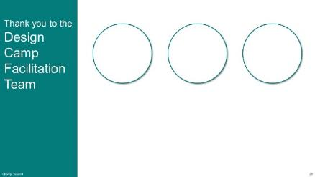
NOTE – IET Training Team:
- This is an optional slide that you can use to thank your facilitation team.
- Tailor the talking points according to your needs.
Present:
- Thank the Design Camp facilitation team for their hard work and for sharing their expertise.
NEXT SLIDE
- Thank you!
Presenter: [NAME]
Duration: 1 min.
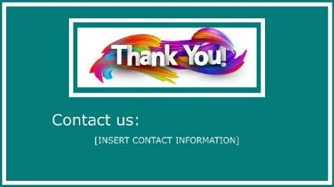
Present:
- Thank the participants for their active participation, provide relevant contact information, and close out the Design Camp.

AFTER THE SESSION

Follow-Up Recommendations
Send an email to participants to:
- Thank them again for their participation.
- Let them know they can still provide feedback on the Design Camp.
- Remind them who to contact for assistance.

