Integrating Digital Literacy Into Adult English Language Instruction (Assignment #3 Extra)

Unit 2: Information and Communication Technologies for Language Learning
Skill Area | Instructions
Activity: Listening | Think about the listening resources that you just explored. In your reflective notes or with a colleague, consider the following questions:  - What units did you identify that would benefit from additional listening practice?  - What listening resources might fit well with each of your identified units?  - For each of the units, what is the purpose for listening?  - What vocabulary items would you need to work into your units?  - What listening strategies could you model and help students learn to use?  - What language elements (e.g., level of formality, sentence structures, forms to request information, and so on) will you bring to the students’ attention?
Activity: Speaking | Think about the way that student-made podcasts can enhance speaking in several units in your class. In your reflective notes or with a colleague, consider the following as you develop a podcast creation activity:  - List three to four units that could benefit from student-made podcasts.  - Who would be the audience for each podcast created? What is the purpose?  - How will the students gather the information that they will need to make the podcast?  - How will the students plan the recording? This may involve writing scripts or interview questions.  - If editing will be required, survey your students to see if any has audio editing experience. If not, what school resources can help?  - How will the podcast be delivered to the intended audience? How will the students get feedback?
Activity: Reading | Think about the reading resource(s) that you explored. Answer the following questions:  - What Internet readings might fit well with each of your curriculum units? Identify the units.  - What supports would your students need in order to do each Internet reading?  - What are the ways that you would help your students select the appropriate links to follow, focus on appropriate images or videos, and evaluate the information?  - How can you support your students’ increasingly independent Internet reading in a way that is appropriate to their level?  - What is the best way to support a mindset of “make mistakes and learn from them” in your class?  - Describe the activity that you designed.
Activity: Writing | Think about your teaching and the need to integrate writing in digital contexts into the curriculum. Select at least one unit (but ideally two units) that could benefit from supplementing the writing component. On the basis of the unit topic, goals, and objectives, select a type of writing (presentation, blog, digital story, or something else) that can align well. Establish a purpose and audience for the piece.  Design an activity for students (individually or in small groups), and consider the following steps (different steps will be appropriate depending on the student and your context):  - Generate ideas and/or collect information.  - Make a plan, encompassing what to include, how to organize it, what language is needed, and the conventions of the genre.  - Provide a language workshop for needed vocabulary and grammar.  - Draft the content.  - Get feedback from student peers.  - Revise the content.  - Get more feedback and revise again (repeat as necessary).  - Edit for grammar and vocabulary and language conventions, such as punctuation.  Answer the following questions about the writing activity that you have designed:  - What unit(s) did you identify?  - What type of writing did you select?  - What are the purpose and audience for the writing?  - What is the writing activity that you designed (see steps, above)?  - How will you “publish” the student products, and how will you get them to the intended audiences?  - How will the students be assessed?
Activity: Vocabulary  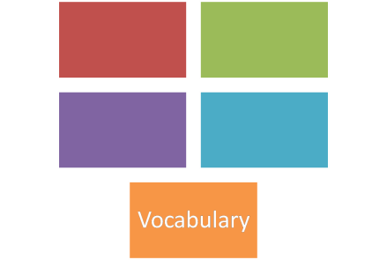 | After watching the instructional video, create your own website and populate it with the vocabulary resources that you have selected as most appropriate for your students. Identify several units that most need additional vocabulary learning, and create one activity (e.g., a vocabulary notebook or vocabulary mini-presentation) for vocabulary learning that can be used across the units that you identified.  Answer the following questions to guide you as you design a website and activity:  - Identify several units that most need additional vocabulary learning. Name the units.  - List the web resources that you selected for your class.  - What activity (e.g., a vocabulary notebook, a vocabulary mini-presentation, or other) did you select? Describe it here.  - Describe the activity that you created.  - What is the URL of your website?

To learn more about teaching adult English language learners, see the Issue Briefs, Companion Learning Resources and Professional Development Modules at https://lincs.ed.gov/programs/eslpro.

